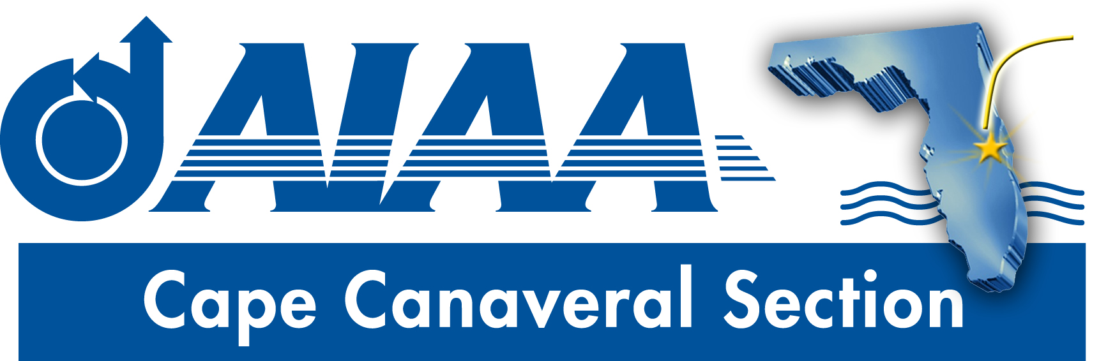
Meeting Minutes for AIAA Cape Canaveral Council Meeting held on March 5, 2020 via Teleconference.
Attendees

Chairperson: | Elizabeth Balga
Treasurer | Matthew Zuk
Secretary: | David Fleming
Communications Officer: | Jacob Shiver
Programs Officer: | Dennis Dali

Elizabeth called the meeting to order at 8:00PM without quorum.
Chair Report (Elizabeth):
- Month in Review: Elizabeth reported on recent activities. Science fair judging, coordinated by Melissa Sleeper has concluded, with good participation from the general membership and council members. Melissa is also working on coordinating the essay contest, which will shortly be distributed to teachers. The recent Public Policy event went well, though the turn-out (around 25 people) was less than hoped. Congressman Posey and the other speakers expressed their appreciation. Having at least one public policy event of a similar nature per year is recommended.
- Upcoming Events: The #BeAnAstronaut event for next week is all set. A tentative date of April 24 has been selected for the Spring Banquet. More details follow later in the minutes.
- Nominations Committee: The process for establishing next year’s council needs to begin, starting with the formation of a nominations committee. Matt reported that according to the by-laws, the Secretary has to be a member of the committee, and Dave agreed to this. Matt noted that we should start by individually reaching out to current council members to see about their interest for continuing, and to poll the general membership. A slate must be formed with at least one nominee for each officer position. Dave suggested that the chair needs to be active in the search to recruit and retain council members. Matt reported that the by-laws do not permit self-nominations. Dave agreed to seek another committee member from the council. Elizabeth polled those on the call about their interest in continuing on the council. Matt indicated that he could continue to serve, but is uncertain. Dave said that he could continue. Jake indicated that his other commitments may prevent his service. Dennis indicated that he probably would not be able to serve. Elizabeth encouraged those not continuing to try to identify replacements.
Treasurer (Matt): Matt gave a summary of the report distributed separately via email. There was income associated with the section collecting registration fees for the FIT dinner meeting in our PayPal account, and CatIII funding for the November networking meeting. Expenses included disbursement of an old Science Fair winner award (who was not present to pick it up in person at a dinner meeting), and other expenses for the past event. Outstanding transactions include checks sent to FIT for the dinner registrations (less our PayPal fees), and the $300 annual support. After these checks clear, $3,675.59 will be available.
Matt was asked how much is available in the YP budget. Matt answered $425, which could be used in support of the upcoming astronaut event. Elizabeth asked about the possibility of purchasing a projector to support that event, and Matt suggested that either the YP line item or possibly another could be used for that purpose.
BeAnAstronuat Event Planning: Elizabeth reported that Bob Cabana will talk about the astronaut application process, and that the event will be a good opportunity for networking among young and mid-career professionals, educators, and more. A room at Rising Tide is booked for 6-8PM. Elizabeth is working on live streaming of the event, and will seek permission from Mr. Cabana’s office. Jake indicated that he applied for permission to advertise the event in KSC’s Daily News, but hasn’t received a response yet. Elizabeth asked for suggestions for a speaker’s gift.
Spring Banquet: Those present agreed that the date of April 24 is suitable. Elizabeth will work with Rachel on logistics. The speaker is still not selected, though the distinguished lecturer program is being investigated. Jake suggested EDS Launch Director Charley Blackwell Thompson as a possibility. Matt suggested the Northrop Grumman director of engineering, and someone from Blue Origin was also floated. Elizabeth asked the council to provide her with specific recommendations and points of contact.
Secretary (Dave): The current newsletter draft is behind schedule, but will include a write up on Mr. Cabana’s recent award, a recap of the FIT dinner meeting and the Public Policy event and science fair judging, and will seek volunteers for Region 2 Student Conference paper judges, and announcement of upcoming event dates.
FIT Student Branch update (Dave): The student branch held it’s annual dinner meeting with guest speaker Todd Barber from JPL. His talk was well received by the students. Between 30-40 people attended, mostly students but also a few section members. FIT students submitted 5 papers to the Region 2 Student Conference, and about 15 students plan to attend.
Communications (Jake): Jake thanked Ashley and Elizabeth for their numerous social media postings.
Action Item Log
- Dave to seek nominees for next year’s council
- Dave to draft newsletter
- All: Planning for Spring Banquet including finalizing speaker selection
Adjourn
The meeting was adjourned at 8:59PM.
Officer List
Chairman: | Elizabeth Balga
Vice Chairman: | Rachel Mocini
Secretary: (also FIT Student Branch Faculty Adviser) | Dave Fleming
Treasurer: (also AIAA Region 2 Finance Director) | Matthew Zuk
Programs Officer: | Dennis Dali
Education Officer: | Naveen Sri Uddanti
Honors & Awards Officer: (also member of Structural Dynamics Technical Committee) | Razvan Rusovici
Membership Officer: | Vacant
Communications Officer: | Jacob Shiver
STEM K-12 Officer: | Melissa Sleeper
Public Policy Officer: | Holly Petrucci
Career and Workforce Development Officer: | Dhuree Seth
Young Professional Officer: (also AIAA Region 2 Asst. Deputy Director of Education) | Ashley Scharfenberg
Technical Officer: | Vacant

