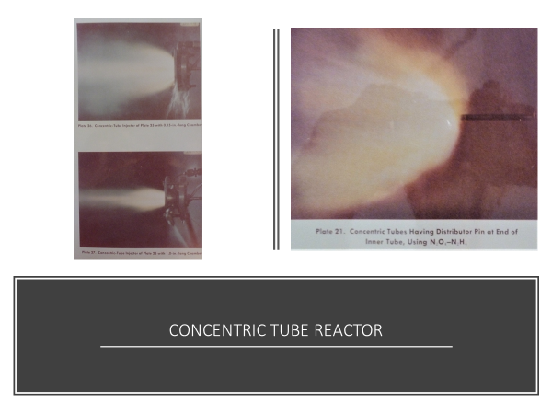
The concentric pair of tubes in the photo on the right has an OD of 0.23inches.
The inner tube has a deflector pin with a small circumferential gap to direct the
propellant in the center tube into the propellant in the annulus. The top photo on
the left shows the tubes fastened to an injector plate with a 0.15- inch adapter ring.
The lower photo has a 1.0- inch chamber attached without a nozzle. The hypergolic
propellants N2O4-N2H4 liquid phase reactions distribute and vaporize the propellants,
and gave good performance in a small rocket chamber of about 30 inch L*.

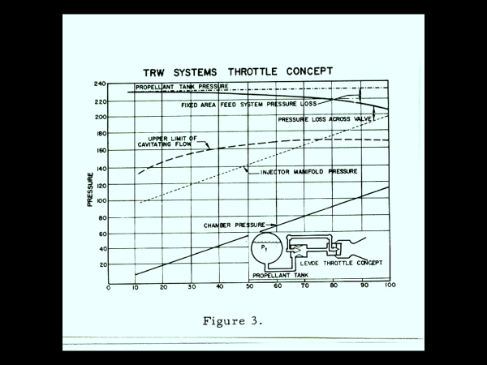

By using a new STL design variable-area Cavitating-flow valve to control the propellant flow rates, the injector pressure drops (propellant stream velocities) into the thrust chamber can be set to their optimum values for best combustion efficiency at every thrust level without affecting the propellant flow rates so long as the up-stream pressure of the injector orifices lies within the values bounded by the upper limit of cavitating flow. It was this separation of propellant flow rates from any down-steam pressure profiles that allowed the engine to operate at high performance over the 10:1 throttle range.

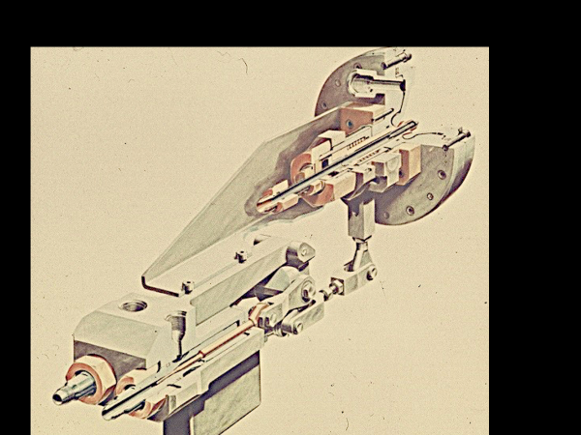
Here is an isometric drawing of the 500 LB thrust engine. We tested it at STL’s small engine facility in Inglewood, CA in 1960 using N2O4-N2H4 over a throttle range from 500 LB to 20 LB. It produced very high performance over the entire thrust range. It was the basis of all STL/TRW/NGC rocket engines used for dozens of Spacecrafts, the Lunar Module Descent Engine, on the Delta stage of 78 Thor Delta launch vehicle flights, for fast response high pressure tactical missiles and more for 60 years; and on into the future.

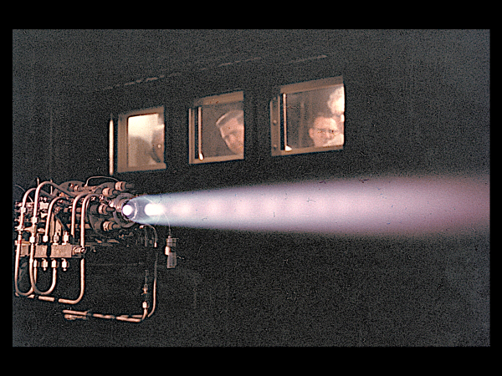
The 500 LB Thrust Engine firing in the small Rocket test Facility in Inglewood, CA. It throttled over 25:1 with high performance over the entire range of thrust. I was a lot younger in those days

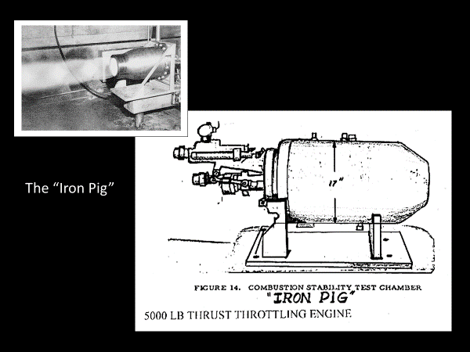
To be competitive for the LMDE Backup Program we had scaled up our 500 LB thrust engine to 5000 LB Thrust. 10 times in one step! However, one of NASA’s greatest concerns was all the trouble they were having with destructive combustion instability. Therefore, they said that when our thruster had to operate in the full LMDE chamber of 17 inches it would probably go unstable. So, as time to submit our proposal was running out, we managed to get a 17- inch diameter iron chamber built with inputs for replaceable “Bombs” that we could set off during firings to try to trigger sustained unstable combustion acoustic modes. We scheduled it for a Saturday morning and Grumman and NASA said we’re coming out! On Saturday morning we were still frantically finishing setting the engine up when they arrived. So, I had to fire the whole set up in front of them with no prior checkout tests! Talk about upset upper STL Management!
But, if I didn’t fire it, we would lose, and if it went unstable, we would lose, SO we fired it setting off many bombs. It recovered from every bomb location test in less than 15 milliseconds! That set of demonstrations at the last minute won us the Backup Program; and as a result, 18 months later we won the final flight engine contract!

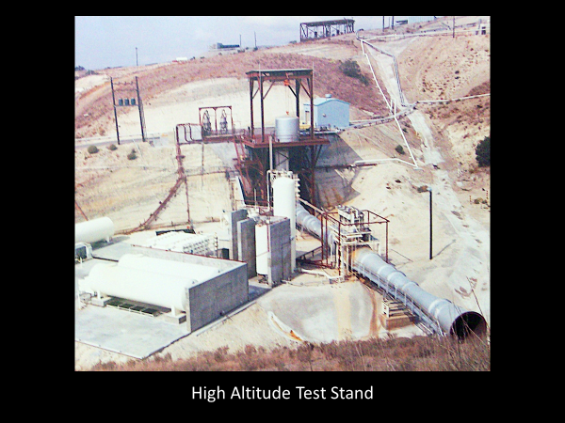
This is the High-Altitude Test Stand [HATS] at CTS. This steam-pumped large vacuum chamber [top center of the stand] allowed testing the LMDE with its full 48:1 columbium nozzle extension over its complete duty cycle. The huge double stage vacuum venturis were pumped by three LOX + Alcohol steam combustors generating a total of 1000 pounds of steam per second!
The first engine development test in this facility was made in August 1964; 13 months after receipt of the TRW Back-up engine contract!

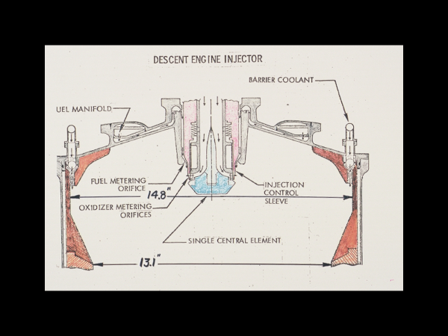

This Cutaway Drawing shows the LMDE Head-end Closure and Coaxial Pintle Injector
with its Red Single Throttling Sleeve. The Fuel Barrier Coolant Flow was used to help the
Ablative Chamber and Nozzle Liner meet its extremely long 1200 second duty cycle.

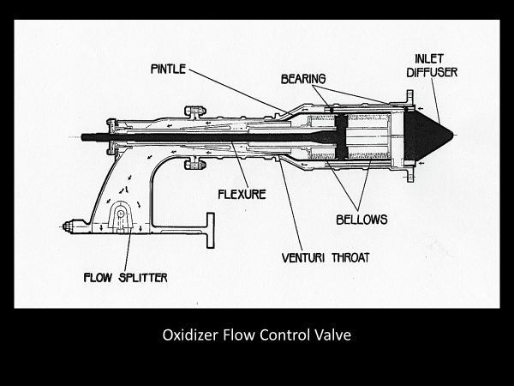
Cutaway of LMDE Flow Control Valve. The Propellant from the Tank enters from the right into the annulus around the control pintle. The annular area is decreased into the venturi throat where the static pressure on the fluid drops to the propellant’s vapor pressure. That limits the propellant’s absolute flow rate for a given tank pressure independent the pressure profile downstream of the venturi diffuser so long as that pressure is below about 80% of the Tank pressure.

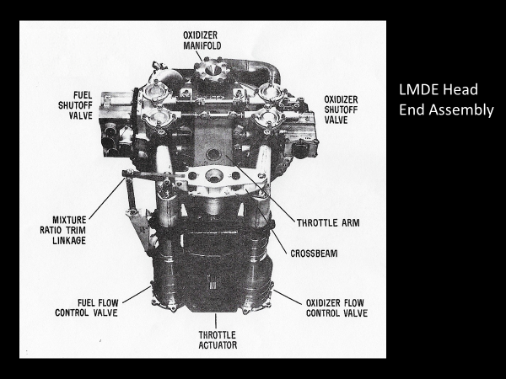
The Integrated LMDE Head-End Assembly showing the cross linkage of the
Cavitating Venturi Valves and the Connecting Arm to the single Sleeve of the Coaxial
Injector. That provided Optimum Injection Velocities for every Flow Rate Setting.

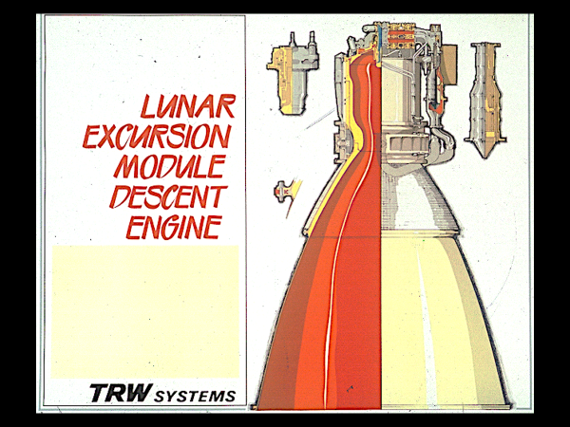
Here is a drawing of entire Descent Engine with the left half cutaway. The interior gas flow area is shown in red. The pressure at the head end of the combustion chamber was 100 psia at full thrust. The combustion gases expand to sonic velocity at the rocket motor throat. The gases continue to expand supersonically with ever increasing velocity and lower pressure out to the exit area of the columbium nozzle. The nozzle exit diameter is 55 inches, and the overall engine height is 90.5 inches. The specific impulse of the engine at full thrust is 305 seconds 297 seconds at 20% thrust.

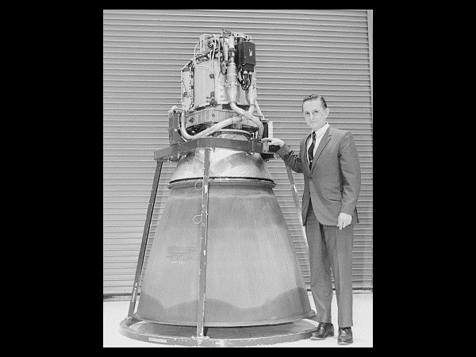
JERRY ELVERUM with his Baby! The first deliverable LMDE, 1967

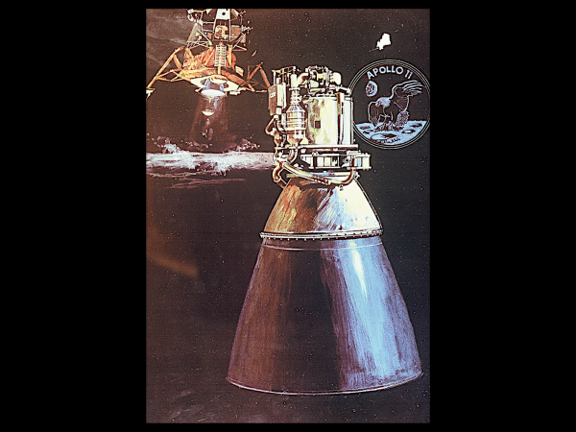
Apollo XI - Humans Landing on the Moon, July 20, 1969. The first time such an event took place in the 4 1/2 Billion-year history of our Solar System!

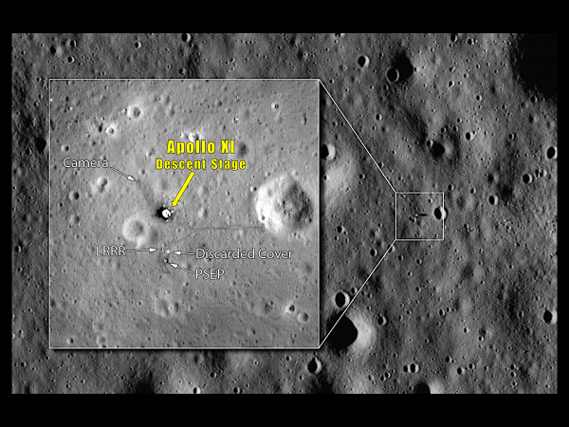
The Descent Stage left behind on the Moon. YES! Humans REALLY were there!

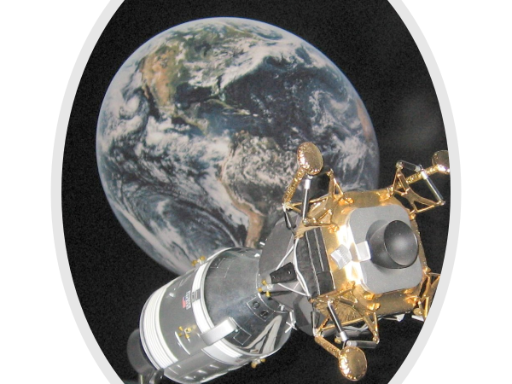
The Descent Engine Returns Apollo XIII to Earth. April 1970

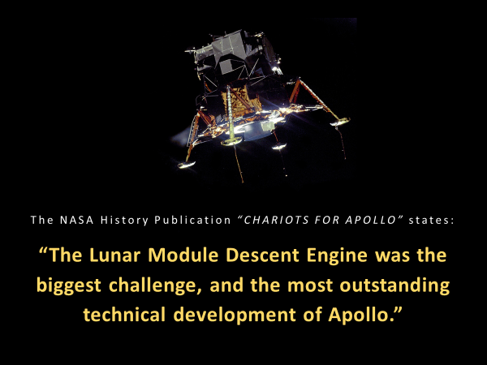

The Legacy of Hundreds of Dedicated Men and Women at STL/TRW, Grumman Aircraft,
NASA and Many Sub-contractors Working under Incredible Time Pressure!

