Council Meeting Minutes
7 February 2023, 6:00 pm – 7:00 pm
Virtual via Zoom

Council Members Present
Chair – Tracie Prater | Education –
Vice Chair – Mark Becnel | K-12 Outreach – Robin Osborne
Vice-Chair (Mobile) - vacant | Liaison to Student Branches – Ian Slamen
Treasurer – Alan Lowrey | YP Director – Christopher Kitson
Secretary – | Liaison to Professional Societies – April Potter
Marketing – | Special Projects – Linda Krause
Honors & Awards – Joe Majdalani | Public Policy – Roy Hartfield
Membership – Bob Tramel | Webmaster -
Immediate Past Chair –
Assistant Webmaster – Jason Pullias

Council Members Not Present
Secretary – Len Naugher
Immediate past chair – Theresa Jehle
Marketing – Denver Powell
Education - Behzad Babamiri

Others Present

Chair
Past events/activities:
- Professional Lecture with Dr. Seyyed Salehian from Tuskegee University
  - January 11th (Zoom)
- ULA tour
  - Friday, January 27th and Friday, February 10th
    - Thanks to Chris Kitson for organizing!
- Rocket City Invitation (Quiz Bowl) at UAH
  - February 4th
    - Thanks to Robin for organizing!
- Professional Lecture on HEXAGON program with Ricky Deutsch
  - February 7th at noon (Zoom)

Upcoming events/activities:
- E-Week dinner
  - Tuesday, February 21st at Jackson Center
  - Chris Kitson leading planning of this event
- Great Paper Airplane Contest at UAH
  - Friday, February 24th
- March professional lecture
  - Dr. Andrew Keys, March 22nd at Downtown Huntsville Public Library
- April and May professional lectures – TBD
  - Speaker recommendations welcome!
- Brews to Benefit at Straight to Ale
  - Need to schedule (usually in April)
- Systems Engineering Workshop at UAH with Dr. Dale Thomas
  - Tentatively looking at Friday, April 14th
  - Behzad (education director) and Allie Brown (UAH student branch chair) leading organization
- Restart of book club (Linda Krause)
- Cocktails and Cosmos at USSRC Planetarium (would be a good evening social)
- Volunteer dinner (May)
- Section awards dinner (May)
  - Need to find a keynote speaker
  - Saturday, May 20th at Jackson Center
- Sackheim Scholarship (May)

Timeline:
February: nominating committee appointed by council
webinar on open council positions
March: call for nominations goes out through marketing e-mail and remains open for 21 days; teller’s committee appointed
April: nominating committee meets and delivers slate of candidates to secretary; ballot put out to section with min. 20 day voting window
May: teller’s committee counts and certifies vote; installation of new council

Vice-chair/Program
No update

Secretary
No update

Special Projects Director
No Update

Membership Director

Feb. 1, 2023
719 Professional
248 College
62 High School
57 Educator
= 1086 Total

Year Prior (Feb ‘22)
754 Professional
255 College
30 High School
149 Educator
= 1188 Total

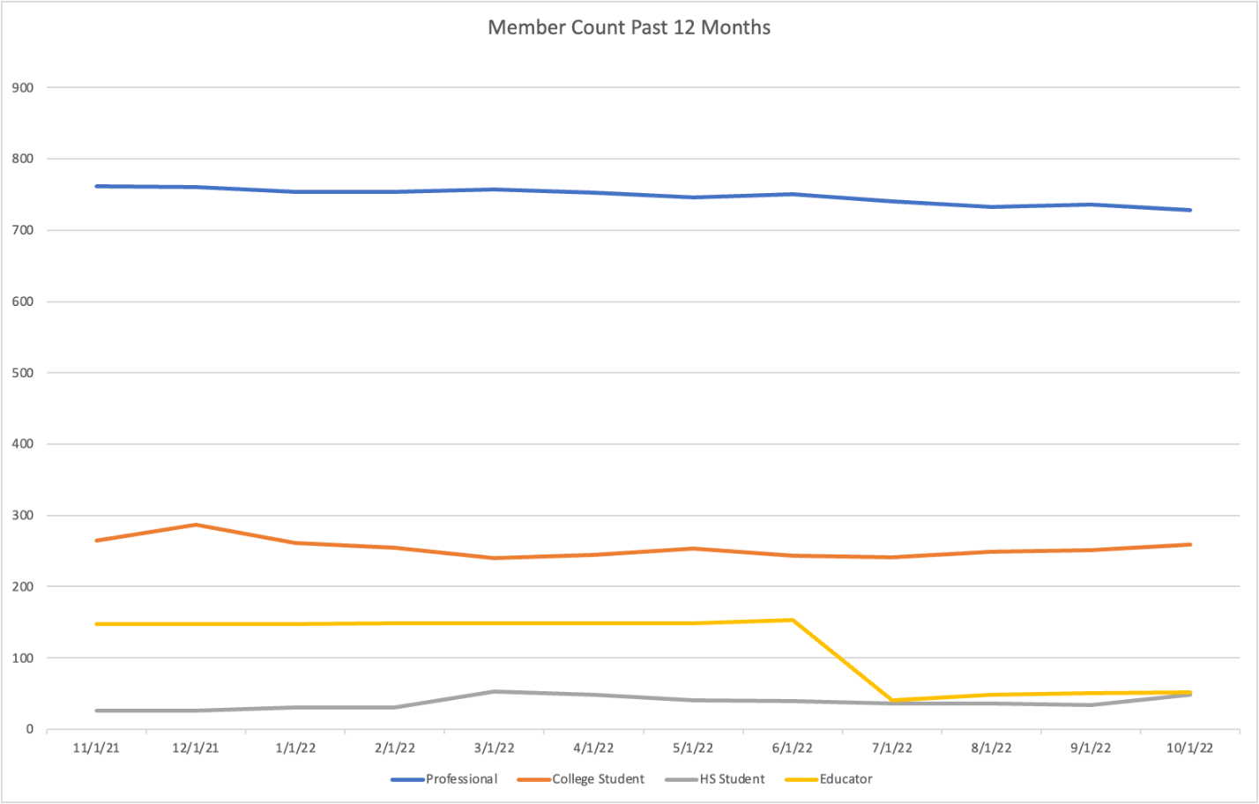

Liaison to Student Branches
Allie Brown (UAH) student branch chair online for meeting
-talked about potential collaborations between UAH student chapter and GHS

Ian Slamen speaking to UAH student branch soon on GHS and activities

Treasurer

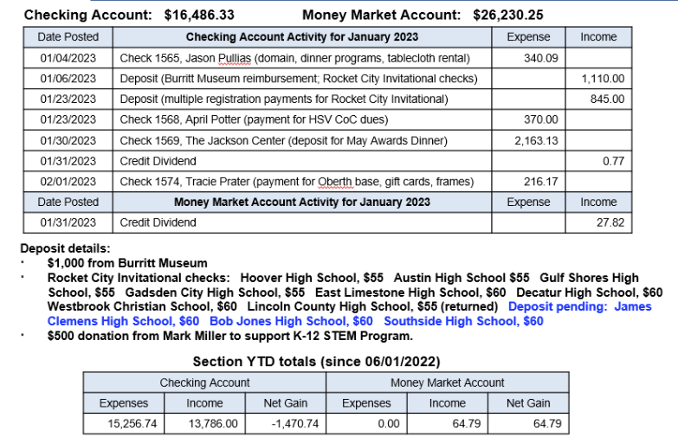
Mobile Chapter
No Update

Marketing Director
No Update

Education Director
No Update

Newsletter Editor
This position is open

Honors & Awards Director
Council discussed section awards dinner in spring at this meeting
Reserved Jackson Center for Saturday, May 20th

Will need to put out call for award nominations in late Feb./March

Need to recruit keynote speaker:
Peggy Lee Wright, The Company You Keep
Chris Crumbly, Victory Solutions
Todd May, KBR Wyle
Paul Gradl, NASA (won Engineer of the Year for AIAA in 2022)
If you have other ideas, send to Tracie and/or Joe

Liaison to Professional Societies
No Update

K-12 Outreach Director
No update

Public Policy Director
No Update

YP Director
No Update

Webmaster
- Continuing to add event articles to website
- Updated site menu to more clearly indicate where past events are located
  - https://engage.aiaa.org/greaterhuntsville/archives/2022
- Let Jason know if you want any changes to website, need Constant Contact or Eventbrite access, etc.

Motions Made, Seconded and/or Carried

Motion #1
I, Tracie Prater, motion to approve council minutes from January 2023.

Seconded by: Alan

Yes: 11 No: 0 Abstain: 0

This motion is: passed

Motion #2
I, Tracie Prater, motion to appoint a nominating committee consisting of the following: Marc Becnel (vice-chair, would serve as chair of committee), Bob Tramel (membership director), Nishanth Goli (section member), Tom Hancock (section member), and Jeremy Fehrenbacher (section member).

We need to appoint a nominating committee in February to keep to the elections timeline discussed at last meeting and have a new council installed by the end of May. The nominating committee approves nominees and provides the slate of candidates to the secretary.

Seconded by: Alan

Yes: 11 No: 0 Abstain: 0

This motion is: passed

Motion #3
I, Tracie Prater, motion to expand the overall E-week dinner budget to 15K. Previous estimate approved by council (~5K) was based on quote from Jackson Center for 100 attendees. We have currently sold 132 tickets and the registration deadline is 2/14. We could have as many as 200 attendees. The section is covering dinners for keynote speaker and guest, 4 volunteers, and the HATS awardee.
Other notes: Event looks to be revenue generating – individual tickets sold at cost and we have 15 table purchases (5 Aerojet, 3 UAH CoE, 3 IEEE, ASCE, 2 Jacobs (via Eventbrite), 1 Tec-USA (via Eventbrite) and 1 AAMU). Cost of printing programs is approximately $450 (200 program @ 8 pages).
Council also approved block of discounted student tickets ($20 each) in quantity of 20.
Original motion was for 11K. Marc Becnel (vice chair) recommended increase to 15K due to uncertainties in scale of event (number of tickets sold) and fact that we will not have another council meeting prior to payment being due to Jackson Center.

Mark/Chris to talk offline about setting up waitlist for students for open/unclaimed seats at dinner.
Seconded by: Mark

Yes: 11 No: 0 Abstain: 0

This motion is: passed

Other:

Council Internal Updates
Policies and procedures document
draft is available for review
Mark will be reaching out for further edits/input
If collectively there are no strong objections current document, may recommend voting on it at a spring meeting and then work other revisions later on

Concerns / Requests
N/A

Action Items and Suspense’s

Previous Council Meeting open actions: (See Action Item List on Google)
Action | Assigned To | Date Assigned

