Council Meeting Minutes
14 March 2023, 6:00 pm – 7:00 pm
Virtual via Zoom and In-person at Tec-USA

Council Members Present
Chair – Tracie Prater | Education – Behzad Babamiri
Vice Chair – Mark Becnel | K-12 Outreach – Robin Osborne
Vice-Chair (Mobile) - vacant | Liaison to Student Branches – Ian Slamen
Treasurer – Alan Lowrey | YP Director – Christopher Kitson
Secretary – | Liaison to Professional Societies –
Marketing – | Special Projects –
Honors & Awards – Joe Majdalani | Public Policy –
Membership – | Webmaster -
Immediate Past Chair –
Assistant Webmaster – Jason Pullias

Council Members Not Present
Secretary – Len Naugher
Immediate past chair – Theresa Jehle
Membership – Bob Tramel
Marketing – Denver Powell

Director of Special Projects – Linda Krause
Liaison to Professional Societies – April Potter

Others Present

Chair
Past events/activities:
- E-Week dinner
- Tuesday, February 21st at Jackson Center
- Thanks to Chris for leading organization of this event!
- April, Mark, Ian, and Alan also helped to execute the E-week event and make it a success!
- Great Paper Airplane Contest at UAH
  - Friday, February 24th
Upcoming events/activities:

- Webinar on council positions – Wednesday, March 15th at noon (registration via Eventbrite)
- March professional lecture
- Dr. Andrew Keys, March 22nd at Downtown Huntsville Public Library
- April professional lecture – Michelle Lucas, Higher Orbits
- Brews to Benefit at Straight to Ale – Monday, April 24th
- Systems Engineering Workshop at UAH with Dr. Dale Thomas
- Friday, April 14th from 10 AM to 3 PM
- Behzad (education director) and Allie Brown (UAH student branch chair) leading organization
- Restart of book club (Linda Krause) – meets third Tuesday of every month at 6 PM; current selection is Carrying the Fire by Michael Collins
- Cocktails and Cosmos at USSRC Planetarium - TBD (would be a good evening social)
- Volunteer dinner (May) – need names of volunteers who helped you in your council position this year
- Section awards dinner
- Saturday, May 20th at Jackson Center; Chris Crumbly, keynote
- Call for nominations currently out until March 31st
- Sackheim Scholarship (May)

Vice-chair/Program
No update

Secretary
No update

Special Projects Director
No Update

Membership Update

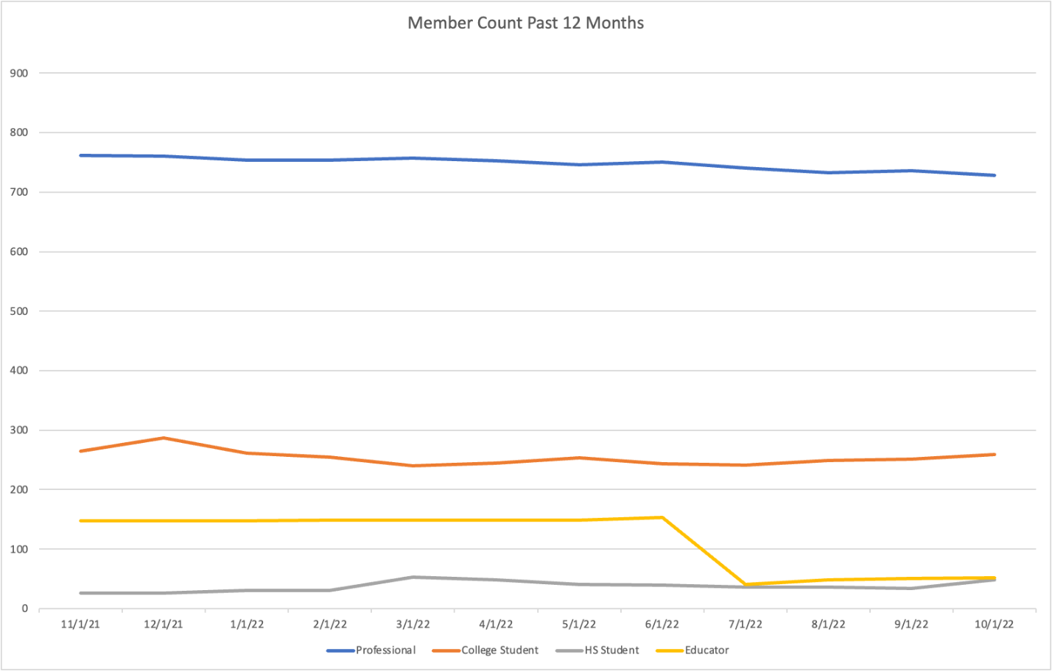
 | 3/1/23 | 3/1/22
Professional | 719 | 757
College Student | 260 | 240
HS Student | 68 | 53
Educator | 57 | 149
Total | 1104 | 1199

Liaison to Student Branches

Treasurer

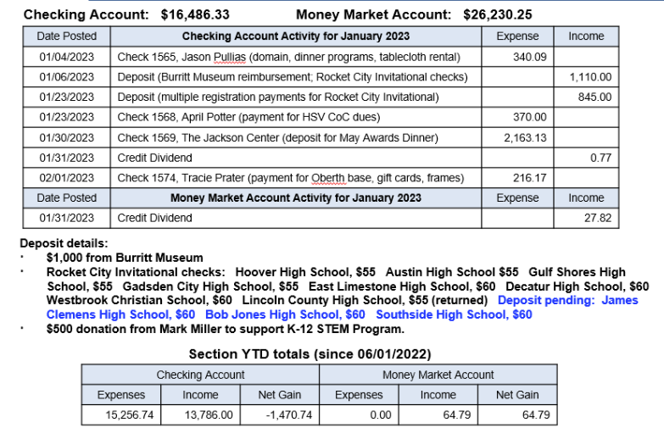
Mobile Chapter
No Update

Marketing Director
No Update

Education Director
Behzad has helped to plan systems engineering workshop at UAH on April 14th from 10 AM to 3 PM
Dr. Gabe Xu reserved room
$500 budget for education in 2022-2023
Charging $10/ticket to cover food (Jason’s Deli boxed lunches)
Amount from Eventbrite we receive will be $7.50; boxed lunches range
from $11-13, so we are subsidizing approximately $3.50-$5.50 per ticket

Limited to 40 attendees (20 professional, 20 student)
Waitlist
Want e-mail to go out to section on 3/17 with registration ending on 4/7
Hybrid event or recording – ask Gabe Xu/Dale

Newsletter Editor
This position is open

Honors & Awards Director
Council discussed section awards dinner in spring at this meeting
Reserved Jackson Center for Saturday, May 20th

Will need to put out call for award nominations in late Feb./March

Need to recruit keynote speaker:
Peggy Lee Wright, The Company You Keep
Chris Crumbly, Victory Solutions
Todd May, KBR Wyle
Paul Gradl, NASA (won Engineer of the Year for AIAA in 2022)
If you have other ideas, send to Tracie and/or Joe

Liaison to Professional Societies
No Update

K-12 Outreach Director
No update

Public Policy Director
No Update

YP Director
No Update

Webmaster
- Added articles for recent events to the Engage web site
- AIAA updated the Officers page to remove email addresses in response to Zelle scam emails
- Distribution@hsv-aiaa.org mailbox moved from Outlook/GoDaddy to Google workspace
  - This was the section’s last dependency on GoDaddy services
  - Access to distribution mailbox is available by delegate access to users with aiaaghs.org Google accounts
- Constant Contact Marketing Email - 1223 recipients
  - 33-45% open rate,
  - 944 current members
  - 186 former members
  - 99 non members / unknown (carried over from GoDaddy list)
- Contact jason@aiaaghs.org for your web/email needs

Motions Made, Seconded and/or Carried

Motion #1
I, Tracie Prater, motion to approve council minutes from February 2023.

Seconded by: Alan

Yes: 8 No: 0 Abstain: 0

This motion is: passed

Motion #2
I, Tracie Prater, motion to amend current policies and procedures document to make public policy position and Mobile chapter vice-chair 2-year positions elected in odd years (in current document these positions are stated as even years).

Rationale: Current bylaws indicate that appointed positions (which would be public policy and education director this council year) only serve until the next council election. Changing public policy position to being elected in odd years ensures consistency with our election ballot for 2023-2024. Mobile chapter vice-chair is vacant and thus should also be on the ballot. Changing these positions to odd years also helps to balance the number of positions on each year’s ballot.

Policies and procedures (passed April 2022): https://drive.google.com/drive/folders/1BStgeT79odkMeYci0WVD7fHwrIiRsl_8

Section III (council positions): A. Vice chair mobile chapter. Change to “This is a two-year position elected in odd years.”

I. Public Policy Director. Change to “This is a two-year position elected in odd years.”

Seconded by: Robin

Yes: 7 No: 1 (Mark) Abstain: 0

This motion is: passed

Motion #3
I, Tracie Prater, motion to refine budget and pricing for May awards dinner and increase total event budget to $10,000. Previous budget authorized by council was $5000. Jackson Center estimate for our event was $4,326.26. This will scale depending on number of tickets sold (food is $47/person + $16.53 service charge & tax). Fixed cost is $1150 (room, bartender).*. Assumption is that section will pay for dinners of the following: 8 awardees, scholarship recipient from last year + parents (3), and keynote speaker and guest (2). We will also allocate $300 for awards programs. Assumption that cost to section for this event (sans revenue) could be $3000-5000 (see next chart).

Recommended pricing for dinner: $55 (non-AIAA member)
$50 (AIAA member)
$35 (student member)
Table pricing: $800

Sponsorships and table purchases for awards dinner are dependent on council members reaching out to organizations which have historically sponsored this event (ex. Jacobs Engineering, Torch Technologies, CFDRC, Dynetics, etc.)
*This is more than the E-week contract, which was specifically negotiated for that event prior to our involvement

Seconded by: Mark

Yes: 8 No: Abstain:

This motion is: passed
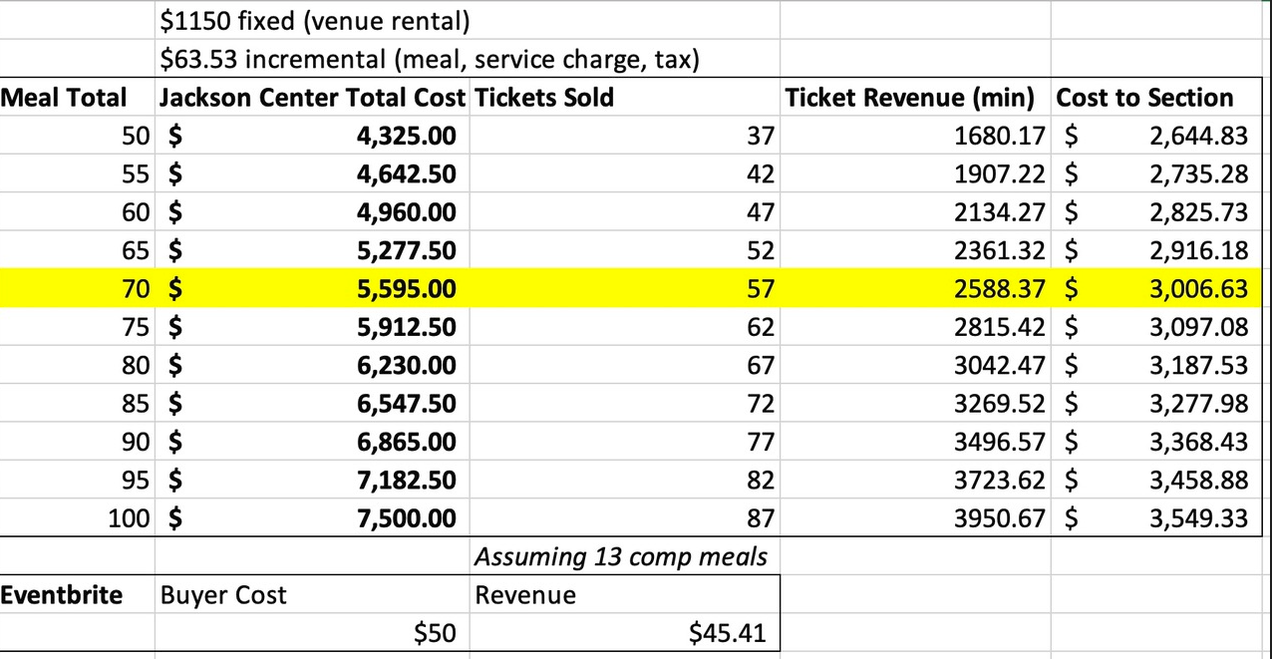

Other:
Sponsorship requests/considerations:

- Higher Orbits
-STEM event in Huntsville in July 2023
-students work over the course of a few days to develop an experiment to ISS and “pitch” the experiment to a panel of judges, event also includes an astronaut
-looking for sponsorships -- $350 and under is most basic level; logo on events fliers, t-shirts, social media mentions
-funds may go to support food for event, scholarships for students, etc.
Already sponsored by AIAA National; based on discussion, council decision to support/cross-promote event, but not sponsor directly

- Student conference (AIAA Region II)
-requested funds for student conference coming up in Knoxville
-$300 in budget for this already, but opportunity to offer more if desired
Based on discussion, Council decision to remain at $300 sponsorship level

- Robotics team for national competition
-request to help sponsor robotics team at Meridianville Middle School.
-Team won the state championship and will be going to the national competition in Dallas, TX
-Any sponsorship amount available – see letter sent to council for details
Based on discussion, council prefers not to sponsor a specific school without program/structure in place to allow other schools to also request funding and metrics to evaluate requests. We may want to consider establishing such a program in the future.
Council Internal Updates
Policies and procedures document
draft is available for review
Mark will be reaching out for further edits/input

Concerns / Requests
N/A

Action Items and Suspenses
Action | Assigned To | Date Assigned
Upload revised version of Policies and Procedures with change  to council position terms voted on at 3/14 meeting | Tracie | 3/14/2023
Write section for P&P document that captures “edge cases” (ex. council appointment to a vacant position that is in 2nd year of 2 year term – position then becomes 1 year position). Bring proposed language to subsequent council meeting for consideration. | Mark | 3/14/2023

