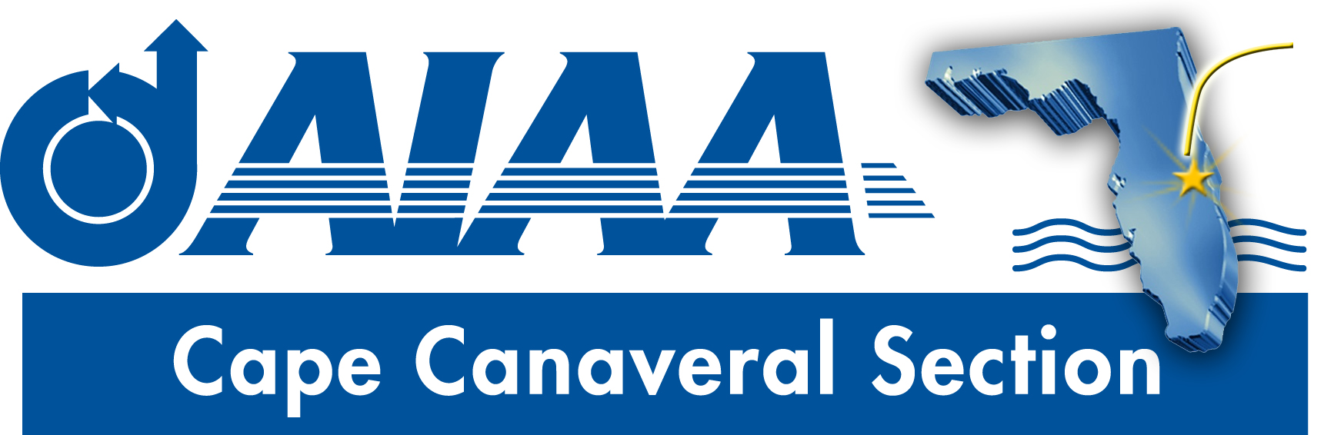
Meeting Minutes for AIAA Cape Canaveral Council Meeting held on January 9, 2020 via Teleconference.
Attendees

Chairperson: | Elizabeth Balga
Vice Chair | Rachel Mocini
Secretary: | David Fleming
Treasurer: | Matthey Zuk
STEM K-12 Officer: | Melissa Sleeper
Young Professional Officer: | Ashley Scharfenberg

Elizabeth called the meeting to order at 8:00PM with quorum.
Council Member Reports
Treasurer (Matt): Full report sent via email includes details of Cat I rebate and recent expenses.
- Money was transferred from the PayPal account to checking to clean up bookkeeping.
- A science fair scholarship to Carl Crutchfield ($200) still needs to be distributed. Rachel has the certificate, but Matt needs to clarify whether Rachel has signature authority on the checking account before she can issue the check.
- The Region has funds available for Cat3 funding, and we should consider possible requests to utilize this opportunity.
- Rachel asked how much money is available in the Public Policy line, as funds of about $200-300 are needed to support appetizers for the upcoming public policy event. Matt replied that the account currently has none. Elizabeth indicated that it would be appropriate to draw from the Lunch/Dinner Programs line for this purpose. In a related issue pertaining to the Pubic Policy event, Elizabeth noted that the venue was not yet selected, but a decision would be reached soon.
The treasurer’s report was unanimously received.
Chair (Elizabeth):
- The revised by-laws, as recommended by national, need to go out to the full section membership for a vote. Matt agreed to lead this effort, as well as to review the new bylaws to see if any new procedures specific to our section should be recommended.
- RAC Report: There has been preliminary discussion regarding the possibility of establishing chapters within the various sections. One benefit of this would be to give more opportunity for local engagement of members in geographically large sections. There have been some discussions that the Central Florida and Cape Canaveral Sections might merge and be rebranded as a “Space Coast” section, for example, with chapters in various locations. Such discussions are all at a very early stage. Elizabeth asked for feedback on this. Dave suggested that a Melbourne chapter within the existing Cape Canaveral Seciton might not be needed because the center of activities currently is not so far from Melbourne, but that chapters might be more attractive for the northern parts of our section such as Daytona or Jacksonville. Melissa noted that the section goes south to Vero, but that there might not be much concentration of membership there to support a chapter. Matt suggested reaching out to geographically isolated section members to gage their interest and find potential leaders of future sections.
- MRO initiative: tabled until February meeting.
- SciTech social with CFL section: Elizabeth reported that there was good attendance, though the event organization could have been better. The event was hard to find, and the venue moved people around too much. However, there were good opportunities for conversation with executive leadership.
- Next SciTech is to be held in Nashville
- Region 2 Student Conference (R2CS) will be held April 6-7 in Tuscaloosa.
- The Next Gen conference is changing its name to the Next Gen Tech Symposium in the coming year.
Secretary (Dave):
- Newsletter. Elizabeth recommended adding a SciTech recap, and a ‘Save the Date’ for the Public Policy event. Information about the R2SC should also be included.
FIT Student Branch update (Dave):
- The date for the Florida Tech dinner meeting is set as Thursday, Feb. 27, and will feature guest speaker Todd Barber from JPL. Dave asked about using the Section’s PayPal account and Matt said that was possible and would set it up. Elizabeth suggested making sure to invite those people from out of town here to support Mars activities.
Vice Chair (Rachel): Rachel reported that her activities are going well. She will try to seek a report from ERAU for the next meeting.
STEM K-12 (Melissa):
- Melissa noted that the three Brevard County science fairs are coming Feb. 8, 15, and 22. We will offer our $200 awards, one for each fair, as usual. Melissa asked for judging volunteers. Elizabeth volunteered for Feb. 8, Rachel for Feb. 15, and Dave for Feb. 22. Judging is in the mornings from 8-noon (approx.). We are welcome to present our award at the award ceremony in the evenings following each fair, though the school will present the winner for us if we prefer. Dave said that the ceremonies are very lengthy; given the limited platform for us to promote AIAA, he recommended against attending the award ceremony.
- Essay content: Melissa indicated that she would reach out to local educators to gauge interest in the AIAA essay contest. If it goes forward, judges from the section will be needed in March. There is some concern that the timing of the contest could overlap with Brevard County Schools’ writing assessment activities which might dampen enthusiasm for participation.
Young Professional Chair (Ashley):
- Attempts to reach out to student branches for possible YP socials has not resulted in any response. FIT was initially interested, but hasn’t responded lately.
- A survey was conducted of AIAA YP members who haven’t participated in YP activities. Ashley will use those results to try to garner more YP support.

Action Item Log
- Matt to check whether Rachel has signature authority for checking account. Depending on resolution, either Matt or Rachel to write check to distribute award to Carl Crutchfiled.
- Matt to review revised by-laws, recommend revisions if appropriate and distribute to section membership for vote.
- Matt to set up PayPal account for FIT dinner meeting.
Adjourn
The meeting was adjourned at 9:03PM.
Officer List
Chairman: | Elizabeth Balga
Vice Chairman: | Rachel Mocini
Secretary: (also FIT Student Branch Faculty Adviser) | Dave Fleming
Treasurer: (also AIAA Region 2 Finance Director) | Matthew Zuk
Programs Officer: | Dennis Dali
Education Officer: | Naveen Sri Uddanti
Honors & Awards Officer: (also member of Structural Dynamics Technical Committee) | Razvan Rusovici
Membership Officer: | Vacant
Communications Officer: | Jacob Shiver
STEM K-12 Officer: | Melissa Sleeper
Public Policy Officer: | Holly Petrucci
Career and Workforce Development Officer: | Dhuree Seth
Young Professional Officer: (also AIAA Region 2 Asst. Deputy Director of Education) | Ashley Scharfenberg
Technical Officer: | Vacant

