Roadmap for Global Agreement on Standards to Advance the Long Term Sustainability of Space
Darren McNight¹, Ruth Stilwell^{2,} Others
Independent Consultant¹, Aerospace Policy Solutions, LLC^{2,}

ABSTRACT

Keywords: information sharing, space traffic management, space environment, orbital debris

- Introduction
The need for international standards and established norms of behavior in space is generally accepted by the space community. In addition to US efforts, the European Union has established a Space Surveillance and Tracking Consortium offering to work in cooperation and competition with the United States. While the need to develop a common understanding of best practices for space actors has general agreement, the path to achieve agreement on standards of behavior is less clear.
This paper evaluates existing opportunities and provides a roadmap for the development of international standards for the purpose of meeting the goal of long term sustainability of space.

- Existing Structures
  - COPUOS
Need contribution
  - ICAO
The ICAO structure for the development of Standards and Recommended Practices (SARPs) for aviation utilizes a formal structure of expert groups, bringing input from states, industry, and aviation professions. Proposals from expert groups are reviewed by the technical commission and a formal process of consultation with contracting states and international organizations. It is important to note that the ICAO process does not require consensus and states are able to formally differ from an ICAO standard, however, doing so requires transparency. ICAO uses this transparency as a mitigation for a lack of consensus.
The ICAO process of developing SARPs is often, and accurately, criticized for being slow and somewhat inflexible. This can impede the timely development of necessary processes for accommodating new technologies and new entrants. A closer examination of the ICAO process as it adapted to rapid change provides a view of alternative available processes. ICAO has the ability to develop guidance material using expert groups, but outside the formal consultation processes. This provides considerable agility in the development of guidance material on best practices, using the operational expertise of states with the most experience with the subject material. This allows states with less capacity or experience to adopt the guidelines, knowing it has been through an ICAO process and will form the basis for eventual SARPs.
The ICAO process for the development of guidance material may provide a model that could be effectively followed using existing international structures for space diplomacy.

  - NextGen-SESAR Coordination
The FAA in the US and the European Union air navigation service providers each launched major aviation modernization programs. These are NextGen in the US and SESAR in the EU. These programs included numerous elements that required interoperability and common operating standards. As these two actors represent the majority of global air traffic operations, the elected bilateral coordination to augment the ICAO process. The approach was an unspoken acknowledgement that the dominate players could create standards that met their needs in the near term and would form the basis for global standards to be adopted later. This approach reflected not only the volume of traffic handled, but the willingness of the parties to invest considerable resources in developing both standards and technology.

  - Other

- Divide the Question
In developing the roadmap, it is recognized that we need to carefully analyze where international agreement is most needed and will yield the greatest benefit for the space community. Efficient use of expert groups should focus expertise on the components of the sustainable space question to enable specialized participation.
  - Space Situational Awareness
Need contribution

  - Space Environment Management
How do we want to describe this concept?

    - Mitigation
Mitigation is a forward looking strategy to limit the addition of new debris in the space environment, this includes standards to require propulsive collision avoidance capability for mission duration and deorbit and to fix requirements for the deorbit of all hardware at end of mission.

    - Remediation
Remediation is required due to objects abandoned before debris mitigation guidelines were put in place and poor mitigation compliance. Remediation is a reflective approach to clean up the current orbital environment recognizing that there is the ability to identify globally selected objects that have statistically greatest debris-generating potential to curtail dead-on-dead debris generation. The risk of collision between two pieces of non-maneuverable debris is do we have statistics on the likelihood or what percentage of conjunction alerts are debris-debris vs satellite-debris

  - Prevention
The prevention of debris creation is the active role often categorized as ‘space traffic management’. Avoiding collisions in space between active satellites or between an active satellite and debris is but one element of a space traffic management regime.

    - Collision Avoidance
Collision avoidance standards should provide predictability to other operators in shared orbits. Operator provided information on intent and planned maneuvers is needed to augment space situational awareness systems. As space becomes more congested, it is necessary to establish common understanding and agreement on right of way or coordinated avoidance maneuvers

    - On Orbit Servicing
Need to elaborate

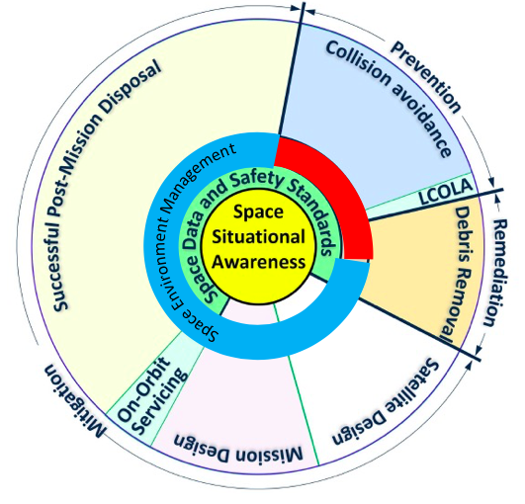
Figure 1: How do we want to title this?

- Key Questions
  - Can existing structures in COPUOS be used to develop guidance material/best practices without requiring consensus?
  - If not, are there other international structures available with the capacity and credibility to lead the effort?
  - What other questions should we be asking?

- Consequences of Inaction
What will happen if we do nothing?

- Steps Forward

  - Near Term
  - Medium Term
  - Long Term
Need material for this section

European Space Policy Institute

