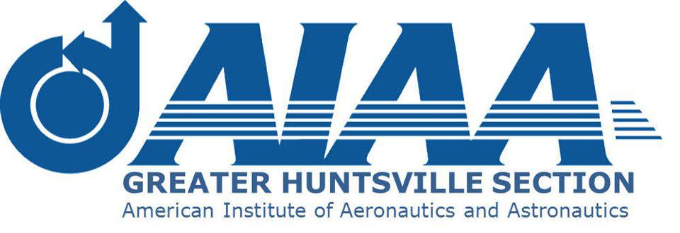

2023 AIAA Greater Huntsville Section Award Nomination Form
Purpose: This form is intended for Section awards, not for AIAA National-level award nominations
Name of Award: [ENTER AWARD NAME HERE]
Award Nominee (must be an AIAA member in good standing at the time of submission):
Address:
Phone Number:
E-Mail Address:
Award Nominator (must be an AIAA member in good standing at the time of submission):
Address:
Phone Number:
E-Mail Address:
Justification (up to 5 one-line bullets/one-row bullets in available font):
Citation (up to 25 words)

Kindly email completed form to: joe.majdalani@gmail.com with copy to: distribution@hsv-aiaa.org Subject: 2023 Section Awards

