Council Meeting Minutes
8 November 2022, 6:00 pm – 7:00 pm
Hybrid – virtual via Zoom and in-person at Tec-USA

Council Members Present
Chair – Tracie Prater | Education – Behzad Babamiri
Vice Chair – Mark Becnel | K-12 Outreach – Robin Osborne
Vice-Chair (Mobile) - vacant | Liaison to Student Branches – Ian Slamen
Treasurer – | YP Director – Christopher Kitson
Secretary – | Liaison to Professional Societies –
Marketing – | Special Projects –
Honors & Awards – Joe Majdalani | Public Policy – Roy Hartfield
Membership – | Webmaster -
Immediate Past Chair –
Assistant Webmaster – Jason Pullias

Council Members Not Present
Treasurer – Alan Lowrey | Special projects – Linda Krause
Secretary – Len Naugher | Liaison to professional societies – April Potter
Immediate past chair – Theresa Jehle | Special projects – Linda Krause
Marketing – Denver Powell
Membership – Bob Tramel

Others Present

Chair
Past events/activities:
- 10/19: “Perspectives in US Hypersonics” with Dr. Colin Tucker (Aerojet Rocketdyne)
  - South Huntsville Library
- 10/22: Von Braun Astronomy Day
  - Dr. Alice Bowman, AIAA distinguished speaker
  - AIAA GHS booth
- 10/28: Huntsville GhostWalk
- 10/29: STEAMFest
- 7 entries in pumpkin carving contest
  - Winners selected via Facebook voting
- First Flight Drawing and Essay Contest (ongoing through November 18th)

Upcoming events/activities:
- 11/29: Professional Lecture with Tinesha Ross, ULA
  - Downtown public library, 6 PM
- Tinsel Trail decorating (social) – 11/19
- Galaxy of Lights Volunteer Night – 12/7
  - Need 4-6 volunteers (currently have 3 sign-ups)
- Associate Fellow Recognition Dinner at Burritt on the Mountain – 12/12 at 6 PM
  - Dr. Roger Launius
- Space policy talk: Ellis Brazeal on 12/13 at 12 PM
  - Virtual lecture
- January professional lecture: Dr. Seyyed Salehian of Tuskegee University
- Systems engineering short course (TBD)
- ULA tour (TBD)

Matthew Hitt resigned as governance advisor for council.

Vice-chair/Program
No update

Secretary
No update

Special Projects Director
No Update

Membership Director

June:
Professional members 750
Student members 243
Educator associates 153
Total 1146

July
Professional members 741 (-9)
Student members 241 (-2)
Educator associates 40 (-113)
Total: 1022

August
Professional members 735 (-6)
Student members 277 (+36)
Educator associates 48 (+8)
Total 1060

September
Professional members 736 (+1)
Student members 251 (-26)
Educator associates 50 (+2)
Total 1037

October:
Professional 728 (-8)
College student 259 (+8)
HS Student 48
Educator 52 (+2)

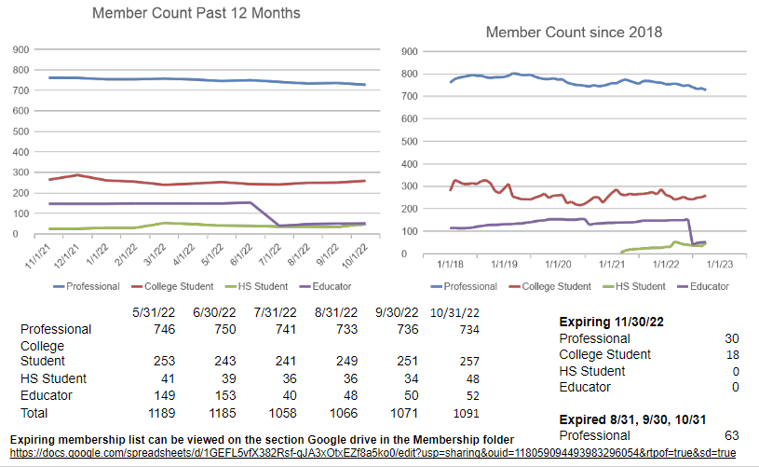

Liaison to Student Branches
No Update

Treasurer

- Balances as of 10/31/2022
  - Money Market Balance: $26,157.30
- (YTD dividend: $41.29)
Checking Account Balance: $21,456.23

Date | Description | Amount | Balance
10/24/2022 | Check #1556: Check  To: Jason Pullas  Constant Contact reimbursement. | -$294.00 | $21,456.23
10/18/2022 | Check #1554: Check  To: Burritt on the Mountain  Site reservation for Asso. Fellows Dinner. | -$2,200.00 | $21,750.23
10/13/2022 | Check #1550: Check  To: Christopher Kitson  Trivia contest gift card reimbursement. | -$100.00 | $23,950.23
10/07/2022 | Deposit  $2,500 from Jacobs.  $55 check from Arab High School | $2,555.00 | $24,050.23
10/04/2022 | Check #1551: Check  To: NAQT  Buzzword Aerospace / Aviation Challenge | -$1,000.00 | $21,495.23
10/03/2022 | Electronic Deposit  PAYPAL / TRANSFER | $5,808.80 | $22,495.23
09/30/2022 | Credit Dividend | $0.69 | $16,686.43
09/20/2022 | Check #1548: Check  To: Amanda Epstein  Chamber of Commerce event reimbursement | -$5.00 | $16,685.74
09/20/2022 | * Descriptive Deposit  DEBIT CARD / DISPUTE PROVISIONAL CREDIT | $0.02 | $16,690.74
09/20/2022 | * Descriptive Deposit  DEBIT CARD / DISPUTE PROVISIONAL CREDIT | $2.00 | $16,690.72
09/15/2022 | Check #1549: Check  To: Arloe Mayne  GoDaddy support reimbursement | -$36.16 | $16,688.72
09/12/2022 | * International Fee International /  Fee US Funds | -$0.02 | $16,724.88
09/12/2022 | * Point Of Sale Withdrawal /  CATHEDRALE STE TRINITE PARIS FR Card #2126 | -$2.00 | $16,724.90
09/02/2022 | Electronic Deposit ERCINC - / EFT 13329 | $1,000.00 | $16,726.90
* Debit Card was “hacked”. Card has been replaced and lost funds restored.

Mobile Chapter
No Update

Marketing Director
No Update

Education Director
No Update

Newsletter Editor
This position is open

Honors & Awards Director
No update

Liaison to Professional Societies
No Update

K-12 Outreach Director
No update

Public Policy Director
No Update

YP Director
No Update

Webmaster
- Key Accomplishments
  - Constant Contact Email Marketing
    - Received reimbursement from Treasurer for Constant Contact Email Marketing
    - Tracie and Robin sent emails to section email list
    - 1091 contacts (918 current members, 77 former members, 101 non-members or carried over from GoDaddy list)
      - 665 members near Huntsville – targeted list for local volunteer opportunities
    - 621 recipients have viewed at least one email in the past 30 days
    - 7 unsubscribes in October (students)
  - Eventbrite
    - Completed Ghost Walk Event – Funds should be deposited by Nov 9
    - Tickets on sale for Associate Fellow Recognition Dinner
  - Engage / Section Web Site
    - No updates – Continuing to list section events in Engage
  - Domain Registration
    - hsv-aiaa.org expires 12/12/2022 – Planning to transfer domain name from GoDaddy to Google. Cost of < $20 / year is part of annual budget
  - Section Mailbox – distribution@hsv-aiaa.org
    - Investigate migrating from Outlook 365 (procured through GoDaddy) to Google for security, usability improvements and annual cost savings.
  - Policies and Procedures - Provided input for Policy and Procedures document on Webmaster duties.

Motions Made, Seconded and/or Carried

Motion # 1
I, Tracie Prater, motion to approve council meeting minutes from October 2022.

Second the motion –
Yes - 7 No - 0 Abstain - 1
Motion passed

Motion # 2
Motion to approve $150 in prizes for holiday social media contest ($50 for adult category, $50 for age 12-18, and $50 for children under 12).

Rationale: Last year the section ran a Valentine’s Day contest on social media where we asked for aerospace-themed Valentine’s Day card submissions. This was an incredibly popular engagement, with over 70 cards submitted. Motion is to continue the competition this year, but re-theme as a call for aerospace-themed holiday cards. Winners are determined by “likes” on AIAA GHS Facebook. 1st place in each category is a $25 gift card, 2nd place is $15 and 3rd place is $10.

Second the motion – Robin Osborne
Yes – 8 No – 0 Abstain – 0

Other:
Policies and procedures document walkthrough and discussion
*Mobile chapter – has historically been difficult to fill vice chair position, but overall council wants to maintain Mobile chapter and try to encourage more engagement from professional members in this area
*balancing elections – currently more council positions are elected in even years vs. odd years. Balancing election slate in terms of number of candidates would require some directors to volunteer to serve a 1 year term vs. a 2 year term and run for their position again in an odd year. Desire to balance slate between years was brought up in policies and procedures committee.
*Roles and responsibilities – current descriptions of positions are not very specific. Action to council members to add more detail on their position and expectations.
*Honors and awards – discussion of honors and awards policies as written in P&P currently. Policies and procedures committee had added more detail on the process. Joe Majdalani will look at this section and make suggested edits.
*election section updated by policies and procedures committee with realistic dates for election milestones based on history.

Council Internal Updates
N/A

Concerns / Requests
N/A

Action Items and Suspense’s

Previous Council Meeting open actions: (See Action Item List on Google)
Action | Assigned To | Date Assigned

Next Council Meeting 8 November | Meeting ended at 20:00 (8 PM)

