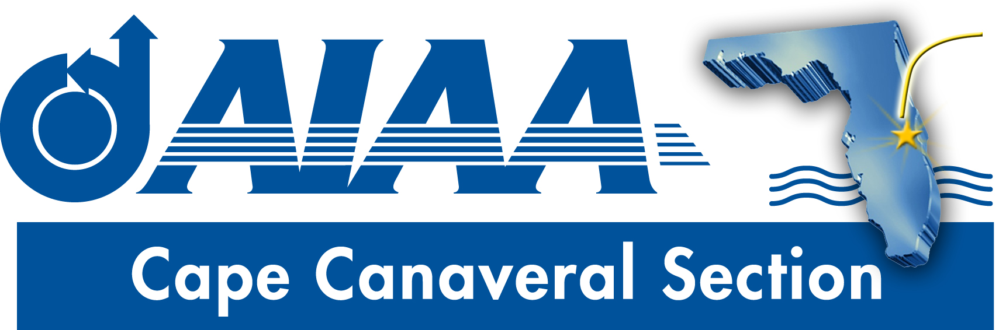
Meeting Minutes for AIAA Cape Canaveral Council Meeting held on April 2, 2020 via Teleconference.
Attendees

Chairperson: | Elizabeth Balga
Secretary: | David Fleming
Communications Officer: | Jacob Shiver

Elizabeth called the meeting to order at 8:05PM without quorum.
Chair Report (Elizabeth):
- Annual Reports: Annual reports are coming due soon, and all officers should be working on getting their sections ready. Elizabeth will ask Matt to send out the latest versions of form templates and copies of last year’s reports to assist with this process.
- Officer Nominations: Elizabeth asked Dave for an update on the section officer nomination process. Dave reported that he has not received any input yet, but has not been as proactive as he should be until now due to being overwhelmed with other concerns. Elizabeth asked Dave and Jacob if they are interested in serving on the council next year. Dave said that he could, in the role of Secretary or a lesser position but wouldn’t have the time available for a higher position. Jacob indicated that work demands may prevent his service. Dave agreed to start pushing the nominations process forward.
- Spring Banquet: Covid19 will prevent the section hosting a banquet in April. Fortunately, there is no venue or speaker that needs cancellation. Elizabeth asked for feedback as to whether it would be advisable to consider a banquet in May, but Jacob and David felt that this time frame would be too optimistic. Elizabeth agreed that the Spring Banquet would be canceled for this year. A summer event can be considered in the future. Some sort of webinar is also a possibility. Elizabeth asked about awards that were to be presented at the banquet. Dave pointed out that the science fair awards are typically given, and that these should be mailed to the winners with a check and a letter from the Chair. Elizabeth agreed to do this, and noted that the winners could be invited to a meeting in the Fall, but it’s unlikely they might attend because they may be graduating seniors and thus might not be available in the Fall. Dave noted that while in the past the Section awarded a ‘Member of the Year’ award, this has not been done for the past couple years and no such plans are currently underway.
- Bob Cabana Event Recap: Elizabeth asked for feedback on the event. Dave said that it was great, and that the video capture was an especially good feature, as he was able to pass the link to two people who are applying to be an astronaut, but were unable to attend. Jacob also said that the meeting worked out well, and noted that attendance was greater than expected, and a larger room might be needed for future similar events. Elizabeth noted that there was very good student turnout, including some students not from the usual places but who traveled a large distance to attend. Elizabeth said that she has been asked to provide a write-up on this event for the AIAA YP Newsletter, and will work with Tammy to do so. She also noted that the section now owns a projector, which we can use in future events. Also, Cat III funding for this event has been received.
Secretary (Dave):
- Newsletter. Dave plans to work on a newsletter in the coming week. Some suggested items for inclusion: review of the Bob Cabana event, announcements for free teleconference courses that AIAA is offering, mention of virtual Air&Space museum tours. Elizabeth suggested including something about Project Possum. Dave will seek a contribution for the member spotlight feature.
FIT Student Branch update (Dave):
- Since the change to virtual instruction at FIT, Dave has not been in good contact with the student officers, but has reached out to them to suggest trying to have some sort of online event to keep morale up. Dave indicated that the R2SC conference organizers have suggested that they may still do some paper judging of submitted papers. He will follow up with them to see if they need any help with judging from the section.
In closing comments, Elizabeth noted that one of the attendees at the Bob Cabana event reported receiving inappropriate communications from another attendee. Jake and Elizabeth reviewed the messages and agree that they are concerning. Elizabeth plans to document the case and report more fully to the council in a future meeting.
Action Item Log
- All: work on end of year reports
- Dave to seek nominees for next year’s council
- Elizabeth to send science fair awards and checks to winners
- Elizabeth to provide material for AIAA YP newsletter on Bob Cabana event
- Dave to draft newsletter
- Dave to contact R2SC organizers Re: paper judging
Adjourn
The meeting was adjourned at 8:33PM.
Officer List
Chairman: | Elizabeth Balga
Vice Chairman: | Rachel Mocini
Secretary: (also FIT Student Branch Faculty Adviser) | Dave Fleming
Treasurer: (also AIAA Region 2 Finance Director) | Matthew Zuk
Programs Officer: | Dennis Dali
Education Officer: | Naveen Sri Uddanti
Honors & Awards Officer: (also member of Structural Dynamics Technical Committee) | Razvan Rusovici
Membership Officer: | Vacant
Communications Officer: | Jacob Shiver
STEM K-12 Officer: | Melissa Sleeper
Public Policy Officer: | Holly Petrucci
Career and Workforce Development Officer: | Dhuree Seth
Young Professional Officer: (also AIAA Region 2 Asst. Deputy Director of Education) | Ashley Scharfenberg
Technical Officer: | Vacant

