Attendees
Kay Sears – Chair
Kevin “Morty” Mortensen – Secretary
Gene Dionne – Member at Large
Erik Eliasen – Vice Chair Montana
Wesley Kenison – ATS
Brandon Tortorelli – Young Professionals
John Grace – Webmaster
Chris Zeller – Programs
Todd Nathaniel – Southern Vice Chair
Agenda
Chair Opening
Roll Call
ATS 2018 Report
Policy Report
Programs Report
Newsletter Report
Membership Report
Webmaster Report
Education Report
New Business
Next Council Meeting
Adjournment
Chair Opening
Kay kicked off the meeting at 6:14pm and welcomed everyone. Kay announced Mike Hamel (LMCO) was selected as a Fellow. The Council send their congratulations to General Hamel and the other Fellows that were selected.

Roll Call
Morty conducted a roll call of members in attendance.

ATS 2017/2018

ATS 2017
A couple of “day of” payments in the total of $116.65 in the form of a personal check and cash was discovered by Andrea Peterson while going through some ATS stuff. I’ve received the funds and will be turning them in at the board meeting.

ATS 2018
Turnhalle still reserved for 09/21/18 for ATS this fall on MSU Denver campus. I’ve had no luck searching for alternatives on campus thus far.

The search for alternative venues has thus far turned up no alternatives that I’ve been made aware of. Joe Rice has suggested that we use the 09/21/18 date. Track Copp is still looking into the possibility of returning to CSM.

Sponsorship checks should have been reissued by Zeiss and MSU Denver for check that never arrived.

Policy Report
Tracy provided the Council the following Policy Committee update:
- Recent: None

- Upcoming:
  - Colorado Aerospace Day (Mon. March 19th, 2018)
    - Registered
    - Details on the event can be found here: http://www.coloradosbr.org/aerospace-day-at-the-colorado-state-capitol
    - Two people tentatively confirmed to work the table – Jason Kuchera, Kristin Shahady
    - Council was asked for additional volunteers to help work the table. Several Council members (Brandon, Wes, Gene and Kay) volunteered to support.

  - CVD 2018 (Tues. March 20th & Wed. March 21st, 2018)
    - As of 2/21 – we have 14 people participating in CVD from Colorado, this is record attendance!
      - 11 of the 14 attending CVD are students, all of them from Mines
    - Financing attendance:
    - AIAA National travel subsidies have been approved (by those who requested them)
      - Total approved subsidies: $2350
        - $250 – professional
        - $2100 – Mines student group (to be split among them)
    - Working with the students to help cover the remaining costs of attendance
      - Mines AIAA student chapter may be able to pitch in $ to help students attend
      - PPC budget has $1700 that can be used to help cover student costs
        - This exhausts the PPC budget for the year
        - Tracy requested that the Council support additional funding, if there is a gap. A motion was made and approved for $500 of additional funding.

  - CU Boulder’s 3rd Annual Aerospace Summit (Thurs. Mar. 22nd, 2018)

- Save the Date!
  - Colorado Capital Conference (TBD)

- News:
  - Additional updates in March on public policy related events, committee direction.

- Opportunities:
  - Define public policy committee direction, focus, gather new ideas and create plans for advancing key issues within the RMS.
  - Leverage Colorado interest groups (e.g. CSBR, CSC, CSE, Space Foundation, Metro Chamber, etc.) to assist in the advocacy of RMS member’s interests/concerns and increase collaboration with the other organizations.
  - Increase connection and collaboration with AIAA National PPC.

The question was asked if we ever get more swag for the tables? Yes, from ATS. Wes will transfer swag to Marshall. Gene also said that he received some from Emily and will provide to Marshall.

Programs Report

Chris provided the following Programs update:

- January31: Gerald Murphy: Design Net Engineering Metro State ~70 attended Lots of Metro State Students
- February 21: H. Levison & T. Halbrook Lockheed Martin Lucy ~70 attended

In Planning:
- March: Sierra Nevada Dream Chaser, Vestas Wind Turbine Plant Northern Colorado/Wyoming, ,
- April: Planet IQ Chris McCormick, April 27 banquet
- May: ULA Vulcan

Honors and Awards

Taylor was able to attend the Council meeting but below was his informative update from last month:

Date: April 27th, 2018 (not an off-Friday)

Venue: The Falls, Littleton, Colorado
The Falls Event Center is an amazing facility offering flexible indoor and outdoor spaces, stunning architecture features, a gorgeous view of the Rocky Mountains, and professional staff supporting your needs for this event. Here are a few of the many amenities we offer that are included with our rental rate:
- Use of all of our tables, chairs, and tablecloths, including setup and teardown
- Use of our Innovative Audio Visual (screens, projectors, TVs, sound system, LED lighting, and more)
- Open Vendor policy which allows you to bring in your own food & beverages, your own decor, entertainment, etc.
- Free Wi-Fi throughout the property
- Absolutely no service charges/hidden fees
On a Friday evening in April, the rental rate is $1,950.

Speaker: Lt Col Tucker “Cinco” Hamilton
Colonel Hamilton is an Experimental Fighter Test Pilot for the United States Air Force. Cinco started his Air Force career as an operational F-15C pilot. He supported multiple Red Flag Exercises and real world Operation Noble Eagle missions where he protected the President of the United States; at times escorting Air Force One. He then served as an Air Liaison Officer in Germany where he was the director of operations for a key command and control squadron. While serving in Germany he was hand-selected to be the initial cadre for the first MC-12 squadron in Afghanistan; heralding in the Air Force's first tactical Intelligence, Surveillance, and Reconnaissance aircraft. He served as the Chief Instructor for 200+ aircrew and accumulated over 400 combat hours directly supporting ground forces. After his time in the MC-12 he attended the USAF Test Pilot School (TPS) where he flew 30 different aircraft, wrote 38 technical reports, and took part in the first Automatic Air Collision Avoidance System testing.

After TPS graduation he became an F-15C and F-15E Instructor Experimental Test Pilot and the Technical Director for the Operational Flight Program Combined Test Force at Eglin AFB, FL. He was the lead test pilot on 11 test programs; supporting the newest software, systems, and weapons for the 450+ F-15 fleet. He then served as the Developmental Test & Evaluation (DT&E) Lead for the Joint Strike Fighter, F-35; overseeing the entire DT&E effort for the U.S. Air Force, Navy, and Marines. He recently transitioned to Edwards AFB, CA where he currently flies the F-35 as the Developmental Test Director of Operations. Cinco has received numerous accolades and awards, the most recent being his recognition by the U.S. Junior Chamber as a Ten Outstanding Young American. He has a B.S. in Aerospace Engineering from the University of Colorado (’02), an M.S. in Aerospace Engineering from the University of Tennessee (’09), and an M.S. in Flight Test Engineering from the USAF Test Pilot School (’12).

Cinco has been heavily involved with AIAA, currently chairing the K-12 STEM Committee. Coupled with his AIAA STEM outreach work he started a non-profit STEM outreach organization, STEM-ED, where he connects teachers to STEM volunteers. Cinco currently lives in California with his wife and four young children.

Added a few days later, Taylor made the final payment. The open question for the Council will be whether we supplement any of the dinner purchases with a drink or two. We will be advertising this coming year’s banquet with ($40/$25) prices for (professional/student) which breaks even at 65 people.

Newsletter

Adrian briefed the following Newsletter update:

The February newsletter was distributed Feb. 16th. The next newsletter is scheduled for April.

Planned Topics for the April newsletter:
* Colorado Aerospace Day (Tracy Copp)
* Congressional Visitors Day (Tracy Copp)
* Fellows Announcement
* Program Summaries
* ‎AIAA Diversity Grants (Tracey Copp)

Kay - for the final newsletter in June, will you be able to write a year in summary for the newsletter coverage "Note From the Chair"?

Membership

Marshall provided the following committee report:

RMS membership is now at 1,360 in total. Professional membership continues to be a concern and has dropped by 20+ to 840 in January. Gene Dionne and John Grace have been analyzing the data showing distributions across Grade and by major Organizations in our Section. Our next objective is to determine what approach is best for attracting new Professional members within the Organizations listed below.

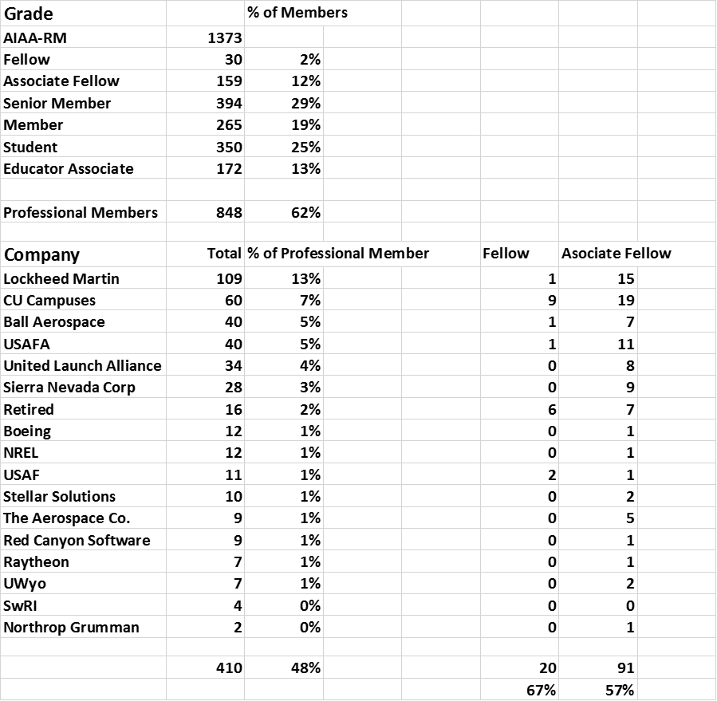

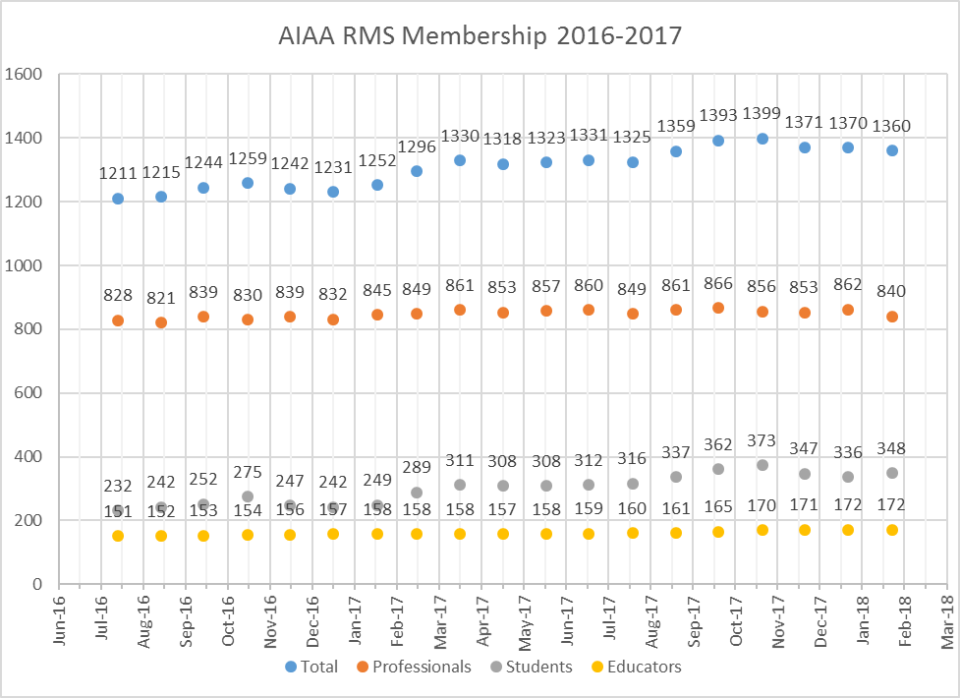

Webmaster Report

John was unable to attend but he provided the following Webmaster report:
- General
- The SharePoint replacement system is an instantiation of Higher Logic called ENGAGE (engage.aiaa.org). AIAA plans open the ability to engage in online conversations very soon, but the release the Section Template will be in “a few weeks.”
- Support
- Registrations: DesignNet, Jan 31 - 13
- Website hits: unknown due to SharePoint issues.
- Email Lists
- Updated the AIAA-RM email list (aiaa-rm@aiaa-rm.org) on Jan 1, 2018. AIAA-RM has 1324 email addresses (down from 1363 in November). Was 1173 in January 2017!
- Since Jan 2015, AIAA-RM has ranged from a low of 1143 (Jul-16), to a high of 1401 (Nov-17).
- Council has 47 email addresses (2 belong to Space Foundation)

Education Report
Sue provided the following on a Student Essay Contest:

For 7th and 8th grade students in Montana, Wyoming and Colorado

The Rocky Mountain Section of the American Institute of Aeronautics and Astronautics (www.aiaa-rm.org) invites you to submit an original essay about astronauts! Research the aspect you choose (use the library, internet, or interview engineers and scientists); then write an essay to describe the role of astronauts and their impact on NASA, their impact on the future of the United States, and their impact on international partnerships. Begin your research at https://www.nasa.gov/astronauts but reach for the stars!

Requirements:
• Student must be in the 7th or 8th grade.
• Double-spaced, typewritten (size 12 font), essay, in 1,000 words or less.
• Include student name, teacher name, grade, school name in top right-hand corner of the essay.
• Include teacher/parent/student contact information (name, phone number, email and mailing address) with the essay for acknowledgement and award notification.

Judging criteria:
• Originality of ideas presented
• Soundness of logic used to develop ideas
• Realism of ideas presented
• Quality of composition and clarity of expression
• Grammar and spelling
• Use of references or quotes to avoid plagiarism

Prizes at each grade level:
• First place $100.
• Second place $50.

Deadline:
• Essay MUST be submitted by March 15, 2018.
• E-mail essays and contact information to essay2018@aiaa-rm.org

The first place winning essays will be forwarded to the 2018 Space Systems Technical Committee AIAA Essay Contest for the national competition and the chance to win additional awards and recognition for the author and their classroom!

Young Professionals

- Hidden Figures Networking event is set for May 10th from 6-10 p.m. at Alamo Drafthouse in Littleton
  - Venue deposit of $587.90 has been made by AIAA
- Still gathering sponsors to cover additional costs and finalize ticket price
  - Total Estimated cost is ~$3600 ($2,950 venue rental, $500 plane ticket, $150 honorarium)
  - AIAA can support $1900 (All of YP’s $900 plus $1000 of John’s budget)
  - Roger, John Marcantonio, and myself decided to try for 5 additional sponsor groups at $250 per group to keep the event diversely and evenly supported. This would give a total of $1250 in sponsorship funding to go towards the $1700 outstanding cost
    - We decided to offer sponsorship benefits of name-dropping on final flyer, event program, and recognized at event, as well as 10 reserved seat ticket purchase opportunities per group prior to opening general registration. This reserves a total of 50 seats for sponsoring orgs and 156 seats for general public
  - The remaining $450 can be covered by selling tickets at $15 per ticket
    - $12 per ticket goes toward attendant’s food & drink minimum
    - $3 per ticket X 206 tickets = $618 with any extra going first towards any unmet food/drink minimum to venue, then the rest towards Dr. Darden’s honorarium
  - Committed/potential sponsors
    - MAIG committed for at least $250 – might donate $500 – does this mean we should allow them to have 20 reserved ticket purchases if we aren’t able to get 5 separate sponsors?
    - Lockheed – Joe Rice’s group is willing to support at least $250
    - Lockheed HOLA chapter – strongly indicating they will support with $250
    - LMLA (Lockheed Martin Leadership Association) – chance they might sponsor with $250
    - Still waiting to hear back from SWE, ASME, CSE, Teledyne
  - Outstanding issues:
    - Could/should sponsors be allowed “tables” or something similar at the event? We are giving them up to 10 reserved seat ticket opportunities.
    - Should we handle registration through Eventbrite or with Taylor Lilly and John Grace’s help using aiaa-rm.org website and Paypal?
    - How can we logistically open early registration for AIAA members only and how long should that early registration period last?
      - Sponsoring groups must still have first chance, then AIAA members, then general public
    - How can we ensure the majority of tickets are actually sold to “young professionals”?

New Business:
- Election for 2018/2019: Morty will send out a call for nominations and suspense nominations for 12 March.
- Treasurer Report: Roger was unable to attend but Kay provided a treasurer update.

Next Council Meeting
The next Council meeting will be 28 March at 6pm at a location in North Boulder area (TBD).

Adjournment

Kay adjourned the meeting at 7:30 pm.

Respectfully submitted,

Kevin Mortensen
Secretary, AIAA RMS

