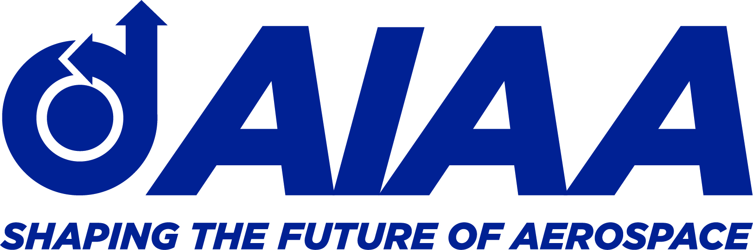
National Capitol Section

2021 AIAA National Capital Section
Hal Andrews Young Engineer / Scientist of the Year Award.

Dear Members of the AIAA National Capital Section:

The AIAA National Capital Section Executive Committee is soliciting nominations for the 2021 AIAA National Capital Section Hal Andrews Young Engineer / Scientist of the Year Award. The nomination package should be submitted as a single pdf file to Norman Wereley at Wereley@umd.edu by no later than April 20, 2021.

The Hal Andrews Young Engineer / Scientist of the Year Award nomination form is below.

This award is the premier award of the AIAA National Capital Section recognizing aerospace professionals in the early stages of their career. This award is presented annually to a local AIAA member who has not reached their 35th birth date anniversary as of January 1 for the year of the award. The nominee must have been an AIAA member for at least one year prior to the nomination form being filed. The award recognizes a single significant professional accomplishment or longer-term outstanding career leadership / accomplishment in the technical disciplines of aeronautics and astronautics.

The 2021 Hal Andrews Young Engineer/Scientist Award will be presented at the Annual Honors and Awards Virtual Ceremony on May 20, 2021.

Successful nominations usually include:

- The nomination form

- A letter of nomination outlining the significance of the nominee's contributions to the aeronautics and astronautics profession in research, development or technology advancement and service or leadership to AIAA and the profession It is permitted to submit endorsement letters supporting the nomination.

- A Curriculum Vitae listing the nominee's professional education, employment history, and professional accomplishments (e.g., journal and conference publications, patents and/or patents pending, service and/or leadership, and any other key information of which you would like to make the selection committee aware.)

- Any additional materials supporting the significance of the nominee’s contributions to the profession (news articles, testimonials, awards, journal or conference publications, etc.)

Please support this vitally important activity of the AIAA National Capital Section and nominate your early stage aerospace colleagues today!

If you have any questions, please feel free to contact me by email.

Yours truly,

Norm
-------

Prof. Norman M. Wereley
Chair, Honors and Awards Committee of the AIAA-NCS
Minta Martin Professor and Chair
Dept. of Aerospace Engineering
University of Maryland
3179J Martin Hall
College Park MD 20742
Office: 301-405-1927
Mobile: 301-910-2272
Fax: 301-314-9001
Email: wereley@umd.edu
CALL FOR NOMINATIONS

American Institute of Aeronautics and Astronautics National Capital Section
Hal Andrews Young Engineer/Scientist Award
(for those 34 years of age or under on January 1, 2021)

The premier award of the National Capital Section is the Hal Andrews Young Engineer/Scientist Award. This award is presented annually to a local AIAA member who has not reached their 35th birth date anniversary as of January 1 for the year of the award. The award recognizes a single significant professional accomplishment or longer-term outstanding career leadership or accomplishment in the technical disciplines of aeronautics and astronautics. The 2021 Hal Andrews Young Engineer/Scientist Award will be presented at the Annual Honors and Awards Virtual Ceremony on May 20, 2018.

Forward your nominee now for consideration for this year.
Nominee: | Member No.:
Professional Affiliation: | Phone No.
Career Background:
Nomination: (Use additional pages if required and/or attach supporting documentation)
Citation: (Must be completed in 25 words or less):
Nominator Contact Information:
Name:
Current Professional Affiliation:
Phone Number:
Email:
Forward no later than April 20, 2021 by email to:

AIAA National Capital Section, Honors and Awards Committee
wereley@umd.edu

For more information, please contact Norm Wereley via email at Wereley@umd.edu.

