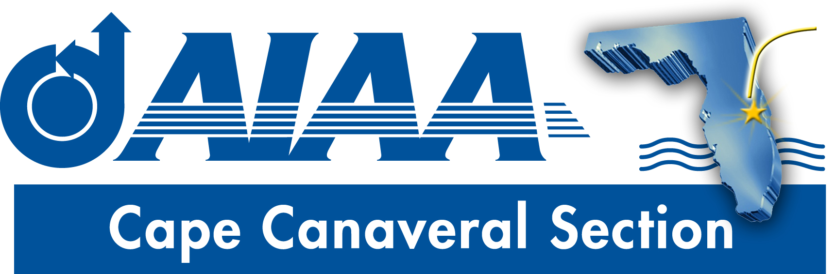
Meeting Minutes for AIAA Cape Canaveral Council Meeting held on September 18, 2019 via Teleconference.
Attendees

Chairperson: | Elizabeth Balga
Vice Chair | Rachel Mocini
Treasurer: | Matthew Zuk
Secretary: | David Fleming
Communications | Jacob Shiver
Young Professional Chair: | Ashley Scharfenberg
Education | Naveen Sri Uddanti

Elizabeth called the meeting to order at 8:30PM with quorum.
Council Member Reports
- Chair (Elizabeth):
- Vice Chair (Rachel):
- Treasurer (Matt): Complete treasurer’s report with financial details are only provided monthly, and thus no formal report on expenses was provided at this bi-weekly meeting. Matt reported that Regional Director Kurt Polzin has requested that sections call recently dropped members to encourage rejoining. He pointed out that HQ has recently created a Top 10 list of talking points about the benefits of AIAA, which could help in this regard. Elizabeth asked Matt to distribute this list to the council. Elizabeth gave a list of upcoming expenses that she foresees:
  - The leadership meeting previously canceled due to Hurricane Dorian will be rescheduled for early November. Cat 3 funding for this is requested.
  - For the upcoming Sept. 30 banquet at UCF, she suggested spending $20 to buy a book by the speaker to be given to an attending section member as an additional incentive for section members to attend. Matt noted that the existing membership/promotion line item can be used for this purpose. Elizabeth said she would proceed with this plan and asked Jake to advertise this fact in upcoming announcements/reminders of the meeting. Jake agreed to do that.
  - Spending for outreach efforts will be discussed with STEM K-12 chair Melissa Sleeper in the near future.
- Secretary (Dave): The first newsletter of the new fiscal year was distributed in August, and the September is in preparation. Both student branches have been approached for a report. Remaining needs are a “Chair’s Corner” and a “Member Spotlight.” Elizabeth and Jake, respectively, agreed to provide those items. Elizabeth also recommended inclusion of a write up on the “Higher Orbits” event. For the October edition, she suggest adding a write up about the “Space Coast Games.” Ashely said that it is too soon to include an update on the Mentor2Mentor effort in this newsletter, but this will be a subject of future article(s).
- Communications (Jake): The section social media efforts are getting more active. Three council members currently have access to the account. He recommended that pictures be first posted on our Instagram account, which will then automatically link to Facebook and Twitter. A goal is to have one post per week. We can also repost relevant items put out by other AIAA sections. Elizabeth noted that content from the newsletter such as Member Spotlights could be extracted and posted as well. Jake noted that the section Engage site needs some updating. For example, the student branches page is empty and the section officers page is not well organized. He will look into ways to better organize the content to better serve section officers looking for material. Jake noted that Dave is not currently listed on the officer page, and will look into correcting that.
- Young Professionals (Ashley): The Mentor2Mentor (M2M) survey is now closed. Many responses were received. 34 people were interested in receiving mentoring and these have been matched with mentors. An email will be distributed soon to get the introductions started. Relevant events are planned to be roughly monthly. As a first event, a social get-together will be held, hopefully with a speaker who will address good mentoring practices and provide some talking points to get discussions started. Many of those who volunteered to be mentors were also interested in receiving mentorship, and Ashley suggest a second meeting among just the mentors to possibly help facilitate that and to ‘give back’ something to the volunteer mentors. Regarding the upcoming dinner meeting at UCF, Ashley asked whether tables could be reserved for M2M participants to initiate some contact. Elizabeth said that as of now there are no assigned tables, but she will check with the Central Florida Section organizers to see if something can be arranged.
- Education (Naveen): Due to technical difficulties, Naveen was unable to call in but sent a report by email: “I have reached out to Embry-Riddle and FIT student branches to promote the enrollment for Mentor2Mentor program. I have included Ashley in the loop so that the sections will have additional contact information for the program. Also, I have sent an email to the student sections about the Fall Banquet of central Florida chapter. I will follow up with them and find out if there are any interested people to attend the event. Once I have the list, I can coordinate and arrange rides to the venue.”
Future planning: Elizabeth asked the council to think about possible speakers for a Fall Banquet to be held by our section. She also raised the possibility of a Winter Social.

Action Item Log
- Matt to distribute Top 10 talking points list to council.
- Elizabeth to purchase book to be given out at UCF meeting as a door prize.
- Dave to publish September newsletter
- Jake to look into improvements to Engage site
- Jake to add Dave to Council member list on Engage
- Ashley to email M2M participants and plan first meeting
Adjourn
The meeting was adjourned at 9:25PM.
Officer List
Chairman: | Elizabeth Balga
Vice Chairman: | Rachel Mocini
Secretary: (also FIT Student Branch Faculty Adviser) | Dave Fleming
Treasurer: (also AIAA Region 2 Finance Director) | Matthew Zuk
Programs Officer: | Dennis Dali
Education Officer: | Naveen Sri Uddanti
Honors & Awards Officer: (also member of Structural Dynamics Technical Committee) | Razvan Rusovici
Membership Officer: | Vacant
Communications Officer: | Jacob Shiver
STEM K-12 Officer: | Melissa Sleeper
Public Policy Officer: | Holly Petrucci
Career and Workforce Development Officer: | Dhuree Seth
Young Professional Officer: (also AIAA Region 2 Asst. Deputy Director of Education) | Ashley Scharfenberg
Technical Officer: | Vacant

