**Mini-Drone Racing**

How the AIAA, Northern New Jersey, Southern New Jersey, and Greater Philadelphia Sections planned and coordinated a drone race event and display at the 2017 New Jersey Wing/Northeast Region Combined Conference for the Civil Air Patrol in Atlantic City, NJ on March 11, 2017.

***Alternatives***

During the planning phase, the team tried to determine what type of drone event would be best. We considered three types of events – 1) Battle – have one team setup a fort of dixie cups then have a second team use their drones to destroy the fort (this concept was used by a Picatinny STEM coordinator); 2) setup an obstacle course (see figure 1 of a table top course) 3) Race.

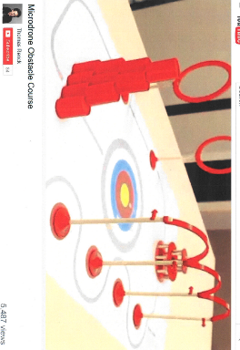

Figure 1: Table Top Obstacle Course

***Capacity Planning***

The team ultimately decided to do a race event. Then the team had to decide the number of drones required. In order to determine this we found out the number of expected attendees (300), divided by the number of sessions (4) so we estimated 75 participants per session (50 minutes). IF we had a race every five minutes then we would have ten races per session, so we planned to have 4 participants per race, that would accommodate 40 people per session because we assumed ½ would not race and thus we decided to host two practice tracks and limit participants to one battery life.

***Drone Requirements***

We looked for inexpensive drones with reasonable performance by google. We found a few options, then one of our colleagues had recently purchased one of our alternatives. He brought in his drone and we tried it out to make sure it was something reasonably simple to control. We ended up with the Eachine E010 (figure 2). According to the specs, the battery life was expected to be approximately 3-4 minutes, and the recharge time was 40 minutes. When we got the items, we observed similar numbers. Based on these numbers we decided to acquire 40 drones and 40 replacement batteries because we assumed 40 racers and 40 practitioners per hour. We also made the assumption that you could not continuously run a single drone and just keep replacing batteries because the drone rotor motors would become overheated.

***Support Material***

Then we had to buy supporting material. The drones came with 4 replacement rotors, one battery and one charging cord. We purchased USB chargers that would allow 14 USBs to connect to one charger (we purchased one and we purchased a 6 hub unit to allow 6 batteries to one USB cord). We also needed AA batteries for the controller. Those batteries should not die within the event time. We made a poster (figure 3) that describes how a quad copter functions, and it had the features of the controller. We emphasized that if the drone gets out of control or goes too high, to pull the left joystick down. We also created a QR code that was linked to our facebook page.

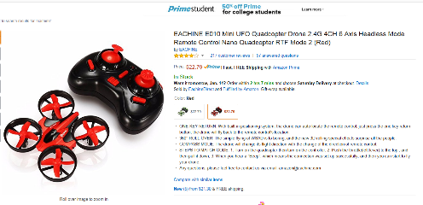

Figure 2: mini-drone Eachine E010

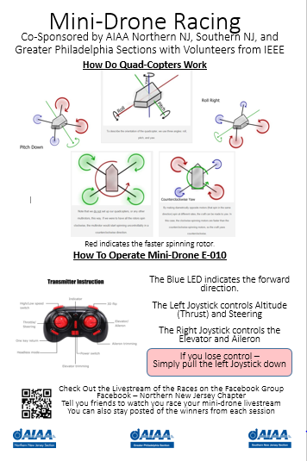

Figure 3: Poster

**RACE Day**

***Prep work***

We had 8 people available for the setup.

We had long animal balloons to serve as the base for the arch. We intended to use additional long animal balloons to make an arch. We ended up using three helium balloons per arch and tied string with three loops.

We had sandwich bags filled with play sand. After determining how large we wanted the arch, we cut the string to length, we tied three loops in the arch. One loop at the center and the other two at two feet on either side of the center. We purchased a helium balloon kit (50 balloons) from Walmart.

We were able to cut the strings to length, tie in the loop, then we took the sandwich bag with the sand the tied the string to the bag in a bowtie fashion (sand in the bag ended up looking like a bowtie). So we had the string ready, tied two long animal balloons together to form the base and blew up the helium balloons. Then when we were able to go into the room we setup a track that was roughly 10’ by 10’.

***Setup***

The arch was formed by place the long balloon pair on the ground then place the sandbags at either end of the long balloon, then tying the helium balloons to the loops. We had a start line then an arch about 5 feet out then another arch perpendicular to the first that was at the 10 ft boundary then a third arch parallel to the first and a finish line. See Figure 4. In hindsight, the string was too thin and did not provide a good visual. Some alternatives would be: a) pool noodle that would be placed on the string between the 1st and 2nd loop and between the 2nd and third loop. B) colorful string or possibly short thick ribbon hanging from the top of the arch. We also had some long balloons (located on ground) popped by the drones, using pool noodles would alleviate that concern.

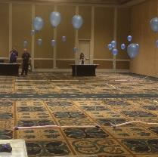 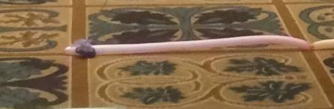

Figure 4: race track setup Figure 5: race track setup – sandbags

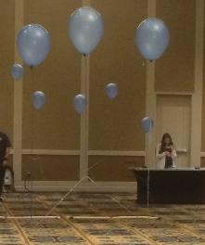

Figure 6: race track setup loops balloons

***Race Time***

We made four tracks (2 practice and 2 race). We had planned to have races on one track with 4 drones per race. But at the event we ended up having one drone per track and raced two racers in head to head competitions with the start line at opposite sides of the room and the finish line being sided by side. This concept worked out really well. The coordinator of the official race wrote each person’s name and provided the raced time by using a stop watch with time split. We would suggest giving the racers a note card so the racer could write their name then the official would put the time on the card and keep the card. We had one time official. Would suggest at least two time official and if available have 1-2 people out on the race track. We had one person and it was barely manageable only because we did not have as big of a crowd as expected. We had a table at each track.

We allowed adults to race but made it clear they were not eligible to receive a prize.

Big issue with the practice track was that some people were controlling other peoples’ drones. When this happened, the setup person had to inform everyone to shutdown their drones and had to initiate a restart procedure. We had one person in charge of this task. We originally had planned to have x number of drones available at the practice track that would stay at the practice track then have the participant get a new drone at the official race track. The participants that raced ended up taking their drone from the practice track to the race track. There was no issue of participants’ battery dying when they were doing the official race. We also found out previously that there may be an issue with wireless phones or other devices that operate on the 2.4GHz. References say that more than 40 devices may cause interference, so if you end up holding the event in one large convention room, rather than a separate room like we had, there may be more of an interference effect. We had one person in charge of synching up the controller and drones. This was probably good that we had only one person, but it would be better to have multiple people knowledgeable so they can trade off as needed.

We had a small crew of people in charge of the batteries, unfortunately they were the same crew that was there for the prep work and the setup work. During the event, our charger became overheated and we had to take it off-line for nearly 30 minutes. We would not recommending more than 14 units per 14 port charger and not to have the charger on continuously for a 4 hour session. Therefore we would suggest that you use one charging station for the first loop and charging then switch to a second charging station for the next charging loop, to allow the alternate charging unit time to cool.

Did not get any pictures of the drones in the air. Recommend getting some action pics. We had video but hard to see.

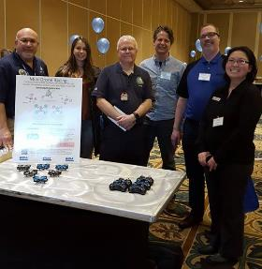

Figure 7:: crew

***Attrition Rate:*** We lost drones in the ceiling. There needs to be a few volunteers that keep an eye on the height of the drones and to warn operators, when they are half way up, to bring the drone down. The drones have a tendency to take off on them. We lost 3 drones.

We also appear to have lost seven drones due to “out of trim”. “out of trim” can be caused by a broken or loose rotor or faulty motor. We have not had a chance to evaluate the seven drones. The volunteer at the setup table needs to be able to attempt to trim the elevator/rudder control to see if the drone can be quickly fixed. It would be best if that was not the controller setup person (which is what we had).

We have not checked to see how many drones we actually pulled out and used but if we approached the 40 mark, then 10/40 lost would be a 25% attrition rate.



The winners is our races ranged from 9 seconds to 14 seconds. Ninety percent were less than 1:45 (one minute – 45 seconds).

***Tear Down***

In our case, tear down was relatively simple. We popped all the balloons and carried out the string with sand bags attached.