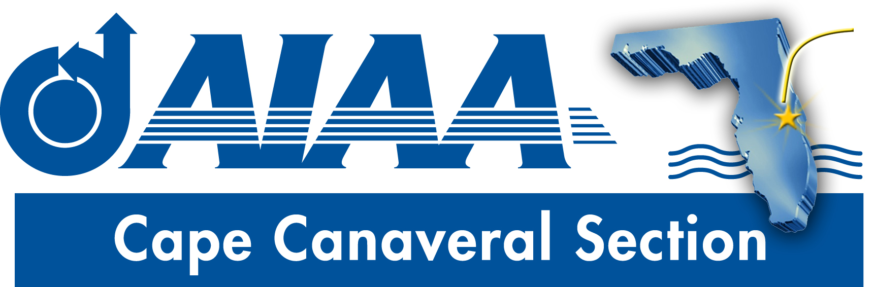
Meeting Minutes for AIAA Cape Canaveral Council Meeting held on November 13, 2019 via Teleconference.
Attendees

Chairperson: | Elizabeth Balga
Vice Chair | Rachel Mocini
Secretary: | David Fleming
Communications Officer: | Jacob Shiver
Young Professional Officer: | Ashley Scharfenberg (9:00)

Elizabeth called the meeting to order at 8:38PM without quorum.
Council Member Reports
- Chair (Elizabeth):
  - National Leadership Visit Recap: Elizabeth thanked those council members who attended the National Leadership visit hosted by the section, including Jake and Rachel. The attendees appreciated the opportunity to interact with She noted that there was a good turnout, with a good mix of participants from all levels including students and professionals at all levels of experience. There were 36 registrants, but an exact headcount from the meeting was not available. The venue and the food were reported as very good, though there was an excess of food ordered (leftovers were sent home with some of the student participants). Rachel and Jacob were tasked to write a short summary of the event for use in the newsletter and social media postings.
  - November Newsletter: Elizabeth suggested new content for the next newsletter: A spotlight on SciTech including a listing of papers at SciTech affiliated with the Student Branches, an update on graduate research at FIT and/or ERAU including information and points of contact for research labs. She also suggested that volunteers could be sought to write op-ed style articles or essays. Rachel noted that she prepared a map of current launch pad status at CCAFS/KSC and would forward that to Dave for inclusion.
  - Holiday Potluck: Planning for the Dec. 7 holiday potluck continues. A Facebook event has been created, but it has not yet been linked to the Engage site. Flyers have been made, suitable for positing via email and social media. She suggested that personalized email invitations should be sent to attendees of recent Section events to encourage these people and to possibly help overcome any awkwardness people might feel about attending an event at the private residence of someone they do not know. Elizabeth asked Rachel if she needs any help with setting up the event. Rachel asked for tables and chairs. Dave said he could provide some folding chairs, and Jake said that he might be able to provide a card table.
  - SciTech: Elizabeth has reached out to the event leadership, but has received only limited response seeking help. Rachel Dowdy indicated that there might be some need to help with the planned Student Branch Leadership Training session on the Sunday of SciTech. [Subsequent to the council meeting, it was announced from AIAA national that they “cancelled the Student Branch Chair training at SciTech for this year.”] There is also the possibility of some sort of social activity associated with the poster presentation session. Jake noted that at the previous SciTech event in Orlando he and the current Section Chair volunteered at the ‘Hub.’ Elizabeth has looked into this, and indicated that the current SciTech leadership did not seem to have such a need this year. Rachel asked if there was a ‘booth’ that students could staff in exchange for free admission. Rachel indicated that there is no word on this yet, and it may not be being done this year.
  - Public Policy Event: Holly and Elizabeth have been working with Congressman Posey’s office and with the Economic Development Commission, but no firm plans have been made yet. Please send Holly or Elizabeth any ideas pertaining to the event. Elizabeth also asked for ideas about the venue for such an event, something more formal that would be good for a panel discussion. Dave suggested that the Sands Space History Museum (http://www.afspacemuseum.org/historycenter/), while not very formal, is a low cost option that the section has used before and might be suitable.
  - January/February Student Dinner Meetings: Elizabeth asked for updates on possible student branch meetings. Dave said that the FIT Student Branch is still intending to hold a dinner meeting, but has not set a date yet. He will prod the Chair to move that effort forward.
  - Other Events: Elizabeth suggested the need to start planning for another Young Professionals event and another Mentoring event. Please let Elizabeth know of any scheduling constraints that would influence planning for these events.
  - Open Section Positions: No nominations for new council members have been received. Please encourage appropriate contacts to volunteer.
  - Budget Reimbursement Forms: Please let Elizabeth know if you need a copy of the form that is used to request reimbursement for section expenditures.

- Young Professional Chair (Ashley): Ashley indicated that efforts to hold a social event near ERAU were not successful. Plans are in the works for a social near FIT in January. Expressing concern about low participation in recent YP events, Ashley asked for the current YP membership numbers. Jake indicated that the number is 68 based on his email listing.
- Vice Chair (Rachel): Rachel indicated that she needs access to member phone number to begin proceeding with the survey. Dave said that he would forward instructions for accessing the Section Roster, which includes phone number info.
Action Item Log
- Rachel and Jacob were tasked to write a short summary of the National Leadership event for use in the newsletter and social media postings.
- Rachel to send Dave map of current launch pad status at CCAFS/KSC for newsletter.
- All to seek candidates for open section positions.
- Dave to email all instructions on accessing section roster.
Adjourn
The meeting was adjourned at 9:14PM.
Officer List
Chairman: | Elizabeth Balga
Vice Chairman: | Rachel Mocini
Secretary: (also FIT Student Branch Faculty Adviser) | Dave Fleming
Treasurer: (also AIAA Region 2 Finance Director) | Matthew Zuk
Programs Officer: | Dennis Dali
Education Officer: | Naveen Sri Uddanti
Honors & Awards Officer: (also member of Structural Dynamics Technical Committee) | Razvan Rusovici
Membership Officer: | Vacant
Communications Officer: | Jacob Shiver
STEM K-12 Officer: | Melissa Sleeper
Public Policy Officer: | Holly Petrucci
Career and Workforce Development Officer: | Dhuree Seth
Young Professional Officer: (also AIAA Region 2 Asst. Deputy Director of Education) | Ashley Scharfenberg
Technical Officer: | Vacant

