Council Meeting Minutes
13 December 2022, 6:00 pm – 7:00 pm
Virtual via Zoom

Council Members Present
Chair – Tracie Prater | Education –
Vice Chair – | K-12 Outreach – Robin Osborne
Vice-Chair (Mobile) - vacant | Liaison to Student Branches –
Treasurer – Alan Lowrey | YP Director – Christopher Kitson
Secretary – Len Naugher | Liaison to Professional Societies –
Marketing – | Special Projects – Linda Krause
Honors & Awards – Joe Majdalani | Public Policy –
Membership – Bob Tramel | Webmaster -
Immediate Past Chair –
Assistant Webmaster – Jason Pullias

Council Members Not Present
Liaison to Student Branches – Ian Slamen
Immediate past chair – Theresa Jehle
Vice chair – Mark Becnel
Public Policy – Roy Hartfield
Marketing – Denver Powell
Education - Behzad Babamiri

Others Present

Chair
Past events/activities:
- Wright Brothers First Flight Drawing and Essay Contest
- Awards will be presented on 12/16
- Tinsel Trail tree decorating (11/20)
- Chamber of Commerce Holiday Reception (12/6)
- Volunteer night at Galaxy of Lights (12/7)
- Associate Fellow recognition dinner at Burritt on the Mountain (12/12)
- Space policy lecture (Artemis accords and Space Debris) with Ellis Brazeal (12/13)

Upcoming events/activities:
- Ugly Sweaters on the Tinsel Trail (YP event) on 12/14
- Aerospace-themed holiday card contest (submissions through 12/20)
- Professional lecture with Tinesha Ross from ULA (rescheduled due to inclement weather)
- 6 PM on January 5th at Downtown Huntsville Library
- Professional Lecture with Dr. Seyyed Salehian from Tuskegee University
- January 11th at noon (Zoom)
- ULA tours
- Friday, January 27th and Friday, February 4th
- Both 30 person tours are full!
- Quiz Bowl at UAH
- February 4th
- Professional Lecture with Ricky Deutsch
- Hexagon film-based reconnaissance satellite
- Huntsville Engineers’ Week Dinner
  - Tuesday, February 21st (pending council approval)

Vice-chair/Program
No update

Secretary
No update

Special Projects Director
No Update

Membership Director
No update

Liaison to Student Branches
Allie Brown (UAH) student branch chair online for meeting
-talked about potential collaborations between UAH student chapter and GHS

Ian Slamen speaking to UAH student branch soon on GHS and activities

Treasurer

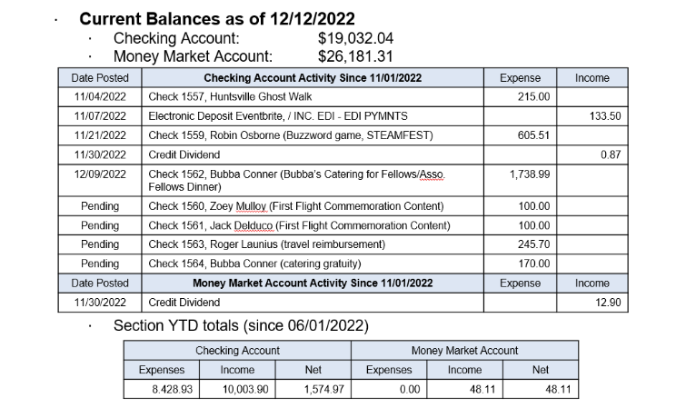

Mobile Chapter
No Update

Marketing Director
No Update

Education Director
No Update

Newsletter Editor
This position is open

Honors & Awards Director
Council discussed section awards dinner in spring at this meeting
Reserved Jackson Center for Saturday, May 20th

Will need to put out call for award nominations in late Feb./March

Need to recruit keynote speaker:
Peggy Lee Wright, The Company You Keep
Chris Crumbly, Victory Solutions
Todd May, KBR Wyle
Paul Gradl, NASA (won Engineer of the Year for AIAA in 2022)
If you have other ideas, send to Tracie and/or Joe

Liaison to Professional Societies
No Update

K-12 Outreach Director
No update

Public Policy Director
No Update

YP Director
No Update

Webmaster
- Key Accomplishments
- Transferred hsv-aiaa.org domain name registration from GoDaddy to Google
- $12.00 annual fee captured in webmaster budget
- Uploaded new articles to website on recent events
- Council members continue to post upcoming events on Engage+Eventbrite and create emails in Constant Contact

Motions Made, Seconded and/or Carried

Motion #1
I, Tracie Prater, motion to approve council meeting minutes from November 2022.
Seconded by: Alan

Yes: 8 No: 0 Abstain: 0

This motion is: passed

Motion #2
I, Tracie Prater, motion to lead organization of the Huntsville Engineers’ Week Dinner. The Engineers’ Week Dinner is a multi-organization event where several entities (companies, other professional societies, universities) give awards. It is typically held at the Jackson Center. The event has not been held in person since 2019 and it is AIAA’s turn to host it.

Motion to reserve Jackson Center for evening of Tuesday, February 21st. Total cost would be $4,945.44 for 100 people (used to get estimate for contract). Cost of a meal per person is $34. Thus actual cost of reserving venue to section is about $1500. We would also need to purchase dinner for HATS award winner (professional of the year) we would honor at event.

Seconded by: Linda Krause

Yes: 8 No: 0 Abstain: 0

This motion is: Passed

Other:

Council Internal Updates
Policies and procedures document
draft is available for review

Concerns / Requests
N/A

Action Items and Suspense’s

Previous Council Meeting open actions: (See Action Item List on Google)
Action | Assigned To | Date Assigned

