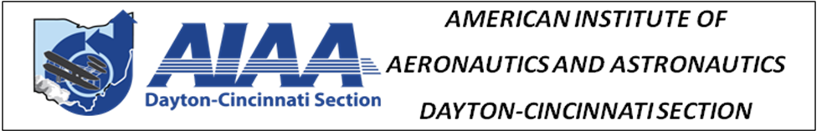

2024 DAYTON-CINCINNATI SECTION AWARDS

CALL FOR NOMINATIONS

Recognize the achievements of your colleagues. The local Awards Banquet is going to be held on May 15th at the University of Dayton. Nominations are sought for several local awards. These include:

Outstanding Technical Contribution - Science Award: Presented to a Dayton-Cincinnati AIAA Section member(s) [limit of 2 people] to recognize a significant scientific achievement during the past year.

Outstanding Technical Contribution - Application Award: Presented to a Dayton-Cincinnati AIAA Section member(s) [limit of 2 people] to recognize a significant development or application achievement during the past year.

Outstanding Management Contribution Award: Presented to a Dayton-Cincinnati AIAA Section member(s) [limit of 2 people] for outstanding management contributions made during the past year.

There is no specific format required. Simply complete the attached form and E-mail the information. Award selections will be made by an expert panel of judges. Submit nominations (by E-mail) by 12 April 2024 to:

Dr. Marc Polanka
E-mail: marc.polanka@afit.edu

NOMINATION FORM
(Nomination Package Must be Limited to 2 Pages)

CATEGORY:
Nominee: Nominator:
Affiliation: Affiliation:
Address: Address:
Tel: Tel:
E-mail: E-mail:
---------------------------------------------------------------------------------------------------------------------

