AIAA Minutes for Feb 08 2021 AIAA Tucson Section Leadership Meeting via Zoom & Teleconference Call
:
AIAA Tucson Section Leadership

Position Title | Name | Email | Attend
Chair | Michelle Rouch | artworkbyrouch@gmail.com | X
Vice-Chair | Teresa Clement | Teresa.clement@gmail.com | X
Treasure | Dan Rouhani | rouhanidxb@yahoo.com | -
Secretary | Steven J Smith Sr | stevenjsmithsr@comcast.net | -
Membership | Rajka Corder | Rajkandavid@yahoo.com | X
Precollege Outreach | Vacant |  | -
Public Policy | Robert Tagtmeyer | robert.tagtmeyer@colorado.edu | X
RAC Representative | Jeff Jepson | - | -
Young Professional | Michael Hotto | mchotto90@gmail.com | X
Webmaster | Eric Hoffman- Watt | eric.hoffmanwatt@gmail.com | -
Technical/Programs | Vacant |  | -
Career Enhancement | Alexis Hepburn | AlexisMFHepburn@gmail.com | -
Honors and Awards | Corey Bullens | cbullens2010@yahoo.com | X
Program | Vacant |  | -
Section gmail account |  | tucsonaiaa@gmail.com | N/A
Regional Public Policy | Matt Angiulo | matt@angiulo.com | X

AIAA UArizona Section Leadership
UArizona AIAA Position | Name | Email | Attend
Student section gmail |  | ua.aiaa@gmail.com
Student President | Matt Banko | mjbanko@email.arizona.edu | -
Student Member | Jett Maher | jtmaher@email.arizona.edu | -
Student Member | Kirk Dahl | kirkdavis@email.arizona.edu | -

Additional Members Attending

Name | Position | Email | Attend
Brian Biswell | Former Chair | drbiswell@mac.com | -
Paul Gastreich | AIAA Member | pegastreich@gmail.com | -
Derek Maldonado | AIAA Member | derekmaldonado24@gmail.com | -
Brett Ridgely | AIAA Member | - | -
Darrel Conway | AIAA Member | Darrel.conway@thinksysinc.com | X
Phillip Witherspoon | Member | pawithers3@gmail.com | -
Peter Laing | Member | c177rg_pilot@yahoo.com | -
Ean Bhilll | Member | Ean.Bhill2@Rolls-Royce.com | -
Jim Kruse | Member | krusequilter@yahoo.com | X
Dale Ward | Member | daledenward@hotmail.com | -
Hunt Gazecki | Member | gazecki.hunt@gmail.com | -
Bernard Parent | Member |  | -
Greg Roberts | Member |  | -
Kirk Hively | Member | Kirk Hively <kehively@yahoo.com> | X
Sandra Raleigh | Member |  | -
Laura McGill | Member | ljmcgill@comcast.net | -
Peter Olejnik | Member |  | -
Mike Michalak | Member | micha306@umn.edu | X
Amy Cooper | Member | acooper279@gmail.com | X
Molly Janasik | Member | janasikm@msu.edu | X

Non- Members that attended 2021 Members Meeting
- Dave Amaker
- Donna Davidson
- Paul Geller
- Dave Ginsberg
- Alan Gleaves
- Frank Gribbin
- DJ Jiang
- Sharan Kalwani
- Bob Kaplow
- Natalie Kuc
- Ron Levine
- Teresa McDowell
- Alan McGhee
- Brian Munn
- Charles Nangle
- Eleanor O’Rangers
- Kevin Pack
- Jack Roosa
- Danielle Roosa
- Nannon Roosa
- Kevin Schindler
- Ann Sederquist
- Tom Wolstenholme
- Michelle Zajac
- Jim (Unknow last name)
- Call in from Tucson

2021 Members Meeting:
Opening Welcome Statements.
Honoring the 50th Anniversary of Apollo 14 mission
Showed general slides
Leadership Council Members Slide
Membership with AIAA Fact Sheet Slide
AIAA National Highlights
1. AIAA continues to work to create an engaging experience and present a vast amount of content. AIAA Tucson section continues to strive to make Meaningful Content for our Members.
2. SciTech had a record number of 1,595 students in attendance.

3. Congressional Visits Day: AIAA is an ADVOCATE for Aerospace. AIAA Executive Director asks to get involved with public policy and please register for Congressional Visit Day (CVD), Week of March 15- Please sign up and participate. CVD Registration Link: https://www.aiaa.org/advocacy/congressional-visits-day
4. 2021 AIAA Elections are now open until Feb 19, 2021. Many Tucson Section members may recognize Laura McGill, who is running for President. Please show your support and vote.
AIAA Tucson Section Upcoming Events Slide
Matt Angiulo introduces Special Guest speaker, Jack Roosa
Jack Roosa offers his personal memories of his late father and Apollo 14 Mission.
Q&A from the guests that attended.
We had approximately 43 people attened. One even as far as United Kingdom.
Teresa Clement offered 4 Trivia questions to the guests to earn a $5 Starbucks gift card.
Michelle Rouch followed up to get their name and email address.
Door Prize for the AIAA Tucson Section Members is a complementary pass to Pima Air & Space Museum on Feb 20 at 10am. Michelle Rouch will contact the members for coordination.

Leadership meeting

Chair Report

- Open Action: Need to announce to the members that we are accepting nominations for the Leadership Committee for the next Fiscal Year.

Vice Chair Report

- By-Laws status
- Next Technical Conference April 17th.- Need Speakers

Treasurers Report
Beginning balance of checking is $17,595.97
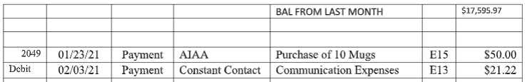

STEM Report
- Open Action : Michelle will inquire again AIAA on how much can be donated per annual budget.
Public Policy Report
- March 11 will be Congressional visit day. Registration is open. All meetings will be virtual
- Robert will take over as the solo chair for Public Policy.

Web
- No Report
RAC Report
- No Report
Outreach
- The Section jointly commented on the amount in Jan 2020 and Michelle Rouch extended the information to the Owner (Melissa Waite), who is willing to accept the $200 amount for the Falcon Heavy Back Pack Rocket. The Falcon Heavy would make a good prop in the booth, especially during comic con events.
- Action Item: Michelle will need to make the exchange and acquire the rocket.
Honor and Awards
- Feb 12 is the deadline date for Associate Fellow for Fellow Class 2021.
- Next meeting we are planning to give shout out to the 2020 new Associate Fellows, Fellows, 25,40, 50, 50+ year members
- Chair will reach out to the new associate fellow members and getting the rest of the supplies for their certificates and getting a final count on the number of shipments. These should be completed by the next meeting.
- AIAA Tucson Section contributes each year to Southern Arizona Research, Science and Engineering Foundation (SARSEF). Rajka Corder will lead the judge effort again, choosing middle school and high school science project, coordinate the scholarship awards to the winners.
Membership
- The Membership Chair will focus on membership upgrades for members to senior members, and sending e-mails asking if they have 8 years of experience. She will also ask if they have worked with one of our leadership members for reference purposes.
- Working with Grant Anderson on his fellow nomination
- Have looked at who can be nominated for Associate Fellow and many were likely not willing to do the additional paperwork to become one.
- Please look into if another member would like to take over membership chair position.
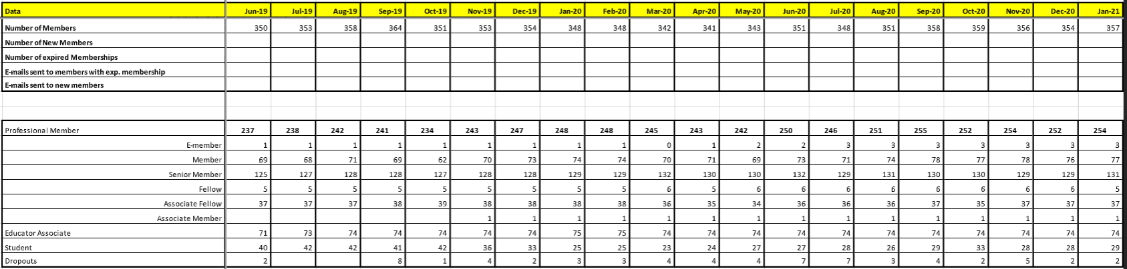
Young Professional
- YP Chair will plan a YP Go Kart, and also set up a YP versus Professional Softball Game
Career Enhancements
- Robert Michalak continues to figure how to reach the Student Branch. Our Section invites them to all our activities. The Section and Branch have communicated for number of years.
- One idea would be to attend one of the Student Branch meetings via Zoom
- Another idea is to meet with the Faculty Advisor, Professor Jekan Thangavelautham. jekan@email.arizona.edu
- Robert Michalak and Michelle Rouch will meet when the Faculty Advisor is available.
University of Arizona
Tucson, AZ 85721
Region: Region VI - West
Section: Tucson
Website: http://uaaiaa.org
Contacts: Student Branch Chair: Matthew J Banko (Email Contact)
Faculty Advisor: Prof Jekan Thangavelautham (Email Contact)

Student Branch
- No Report
Next meeting will be on 1830, March 8 2020

