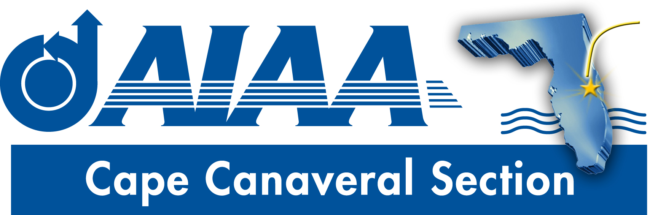
Meeting Minutes for AIAA Cape Canaveral Council Meeting held on October 2, 2019 via Teleconference.
Attendees

Chairperson: | Elizabeth Balga
Vice Chair | Rachel Mocini
Secretary: | David Fleming
Education | Naveen Sri Uddanti

Elizabeth called the meeting to order at 8:37PM without quorum.
Council Member Reports
- Chair (Elizabeth): Elizabeth recapped the joint dinner meeting held with the Central Florida Section, featuring Robert Zubrin as speaker. Overall it was a successful event and well attended (approx. 70). The speaker was interesting and provocative. The audience response during Q&A was very enthusiastic, with the speaker taking questions well beyond the scheduled end time. Some points for potential improvement were noted. The dinner (take out barbecue fare) was somewhat lackluster; using the word ‘banquet’ for the event was not accurate. On the other hand, ticket price was low, which probably partly accounts for the large student turnout. The advertisement/flyer for the event (prepared by the Central Florida Section) should have included better instructions regarding where to park and a guideline on expected attire. Rachel added that she really enjoyed the speaker, but would have liked a little more ‘flair’ in the dinner part. Dave echoed Elizabeth’s and Rachel’s comments, and added that disappointment in the food may have been less if expectations were established in advance. Elizabeth said that in future partnering our section will take a greater role in the planning.
- Education (Naveen): Naveen reported that he has been in contact with the ERAU student branch, which has begun preparation for an upcoming dinner meeting (date, speaker TBA), and is sponsoring a group of students to attend SciTech.
  - As a follow up, Elizabeth reported that she received a request through the ERAU student branch asking for support of one of their projects. The section budget does not support a request of the magnitude asked. However, she noted that she call poll the section membership to see if mentors or other support from members can be provided. Naveen will get in touch with the relevant faculty member to discuss, and will coordinate with Elizabeth on any further actions. Elizabeth also noted that this effort can be spotlighted in the newsletter and our social media feeds.
  - Elizabeth asked if the FIT student branch is planning a fall dinner. Dave responded in the affirmative, but that it is expected in the late Jan. or early Feb. timeframe. Planning is at an early stage. Regarding the Education Chair’s report, Dave requested that Naveen keep in touch with both student branches to facilitate de-conflicting major events between the sections. Elizabeth encouraged having section representation at the student dinner meetings.
  - Elizabeth address the idea that the section could work with the student branches to provide services such as a career session, mock interviews, resume writing workshops, etc, and that Ashley has also expressed interest in helping in that regard. She asked Dave and Naveen to provide dates of upcoming campus career fairs so that such support could be timed to support such events. Naveen added that some of the items mentioned such as resume support are provided by ERAU campus services, but other items on the list may be of greater interest. He suggested coordinating internship needs as one possible idea. Dave suggested that a panel discussion on ‘How I got my first job’ might be a good event. Dave and Naveen are tasked to poll the FIT and ERAU student section leadership about what the greatest needs are and to get back to Elizabeth.
  - Elizabeth noted that Ashley is planning the first Mentor2Mentor events. The first will be held in proximity to ERAU, the second near FIT. Details will follow. Elizabeth asked for recommendations on a speaker about mentoring best practices. Dave said he would seek such a speaker from Florida Tech.
- Secretary (Dave): Dave prepared minutes for the previous meeting, but the first reports need to be added since he joined the meeting late. There is also not a quorum for voting. Vote on these minutes was tabled to the next meeting. The September newsletter was distributed to the membership. The October edition is in preparation, and is expected to include a report from the FIT student branch. Dave asked for a volunteer for the Council Member Spotlight feature, and Naveen agreed to do it. Deadline in 2-3 weeks. Elizabeth asked that a piece on the two new Associate Fellows be included. Elizabeth asked to make sure the newsletters are added to the website. Dave asked for help in finding the membership roster in Engage so the mailings can go to the latest list.
- Vice Chair (Rachel): Rachel prepared a set of questions to be used in phone calls to section members to explore their interest in section activities, etc. These were distributed to the council via email. She asked for feedback on the questions. Dave asked whether it is planned to call the full membership or just a sample, since the workload would be very high to try to call everyone. Elizabeth suggested a sample, with council members calling approximately 10 members each. The script should emphasize a ‘non-threatening’ approach, and be just a few minutes per call.
Other Business
- Holiday Potluck Dinner: Elizabeth and Rachel have begun planning for a Holiday Potluck event. This event will be held at Rachel’s residence in Suntree. The intent is to have a family friendly event, with board games or similar activities. Two main dishes will be prepared by the section and the rest of food will be brought by guests. A single RSVP collection point will be established to coordinate the guest list and what items will be brought, perhaps using the ‘Perfect Potluck’ app. Elizabeth recommended keeping the address of the event private until people RSVPe, but Rachel said that she was not concerned about that and having the address readily available will help attendees.
- National Leadership Visit: The National Leadership visit is rescheduled for Nov. 5. Elizabeth encouraged council members to attend.
- Business Cards: Following an email discussion on this subject, Elizabeth is ordering section business cards. No personal names will appear on the cards, but they will include section email and social media contact points.
- SciTech: Elizabeth has been reaching out to organizers.
- Meeting participation: Elizabeth is planning to participate in the upcoming CCTS meeting, as well as a meeting of the Florida Space Coast Economic Development Commission and the Aerospace Alliance Summit. She hopes to identify possible speakers at these later events.
- Midyear Elections: Elizabeth suggested holding a midyear election to fill vacant council positions. Dave noted that the bylaws allow for Elizabeth to appoint an appropriate volunteer. Elizabeth asked for suggestions on people to fill the slots.
- YP Social: A YP movie night has been suggested for Oct./Nov. Contact Ashley to help plan this event.
- SWE Joint Meeting: Early talks have been held regarding a joint AIAA/SWE meeting.
- Public Policy: Holly has been in contact with the offices of elected representatives to see about their speaking to the section. The Central Florida section is interested in helping with such events. A Public Policy panel discussion is also a possibility. Such an event may be in the January timeframe.
- Meeting schedule: The section has been having a telecon meeting on a two-week scheduled as opposed to a monthly schedule, and some section members have raised concerns about the frequency in light of other responsibilities. Elizabeth said that she prefers to have multiple ‘touch points’ for people to make contact, and that direct contact is often the best way to get things done. If anyone is not able to participate in every bi-weekly meeting that is OK, once a month participation is fine.

Action Item Log
- Naveen and Elizabeth to coordinate response to ERAU student branch regarding support request.
- Dave and Naveen to poll student branches about what sort of career development support the student branches would like.
- Dave and Naveen to send Elizabeth dates of upcoming campus career fairs.
- Dave to seek speaker on mentorship.
- Naveen to provide member spotlight info to Dave for newsletter.
- All: provide feedback to Rachel on phone call script.
- All: provide suggestions on filling vacant officer positions.

Adjourn
The meeting was adjourned at 9:29PM.
Officer List
Chairman: | Elizabeth Balga
Vice Chairman: | Rachel Mocini
Secretary: (also FIT Student Branch Faculty Adviser) | Dave Fleming
Treasurer: (also AIAA Region 2 Finance Director) | Matthew Zuk
Programs Officer: | Dennis Dali
Education Officer: | Naveen Sri Uddanti
Honors & Awards Officer: (also member of Structural Dynamics Technical Committee) | Razvan Rusovici
Membership Officer: | Vacant
Communications Officer: | Jacob Shiver
STEM K-12 Officer: | Melissa Sleeper
Public Policy Officer: | Holly Petrucci
Career and Workforce Development Officer: | Dhuree Seth
Young Professional Officer: (also AIAA Region 2 Asst. Deputy Director of Education) | Ashley Scharfenberg
Technical Officer: | Vacant

