Reinventing Space 2013 and The Orange County Section

The Orange County Section co-sponsored the October 14-17 Reinventing Space Conference for 2013 (reinventingspace.org) continuing a tradition established since its inception. Several members of the Council were there for all three days. The program was full although somewhat modified from the original plan because of the United States government shutdown. The pictures shown here are of our Membership booth set up at the Conference. The website has the details and the papers will be available to the public in about 3 months from the date of the Conference.

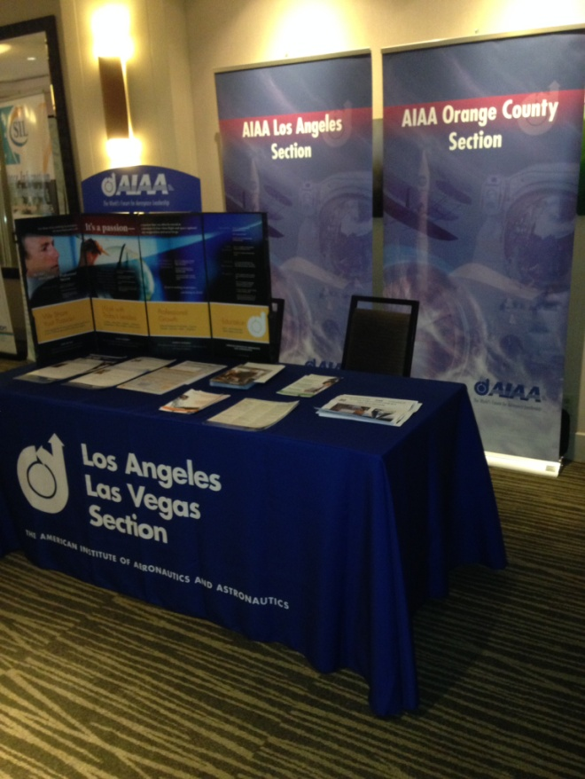 | 