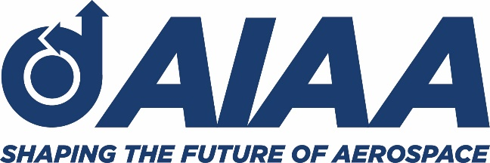
National Capitol Section
Outstanding Educator of the Year Awards
Greetings!
The American Institute of Aeronautics and Astronautics National Capital Section (AIAA NCS) sponsors an Outstanding Educator of the Year Award for science and mathematics teachers from Maryland, Virginia, and the District of Columbia. We would like to provide you with an opportunity to nominate a member of your faculty or the community in which you live.
In the current setting of online and hybrid instruction, we believe it is all the more important to recognize the hard work and commitment of our teachers and educators! The AIAA NCS provides three awards to recognize outstanding Science, Technology, Engineering, and Mathematics (STEM) educators: one each at the elementary, middle, and high school levels. This year we are seeking nominations from AIAA NCS members for outstanding teachers in any or all three categories.
Eligibility criteria to receive the AIAA NCS 2020-21 Outstanding Educator of the Year Award:
- The nominee must be a science or math instructor who provides instruction directly to students.
- Department Chairs and resource teachers can be nominated, but they must provide instruction to students in addition to their administrative position.
- Additionally, AIAA NCS will evaluate your nomination for the educator's demonstrated commitment to STEM education and their degree of external classroom endeavors (such as membership/leadership in professional organizations, after-school volunteer activities, etc.).
If you have a STEM educator who meets the requirements, we encourage you to nominate him/her on behalf of your school. Please use the nomination form below.
The winning educators will be celebrated at the AIAA NCS Annual Honors & Awards Ceremony, scheduled for Thursday, May 20th. A plaque and a cash award of $250 will be presented in recognition of excellence in teaching and contributions in furthering STEM Education in the classroom. Along with these awards, winners will be eligible to apply for the following benefits designed to assist them in continuing to make lessons come alive with projects that will inspire and engage:
Classroom Support: A free AIAA Educator Associate membership, which will put the teacher in touch with scores of engineers in the local community who are willing and able to help in the classroom.
Classroom Grants: The opportunity to apply for AIAA Foundation grants which provide for standards-based hands-on inquiry projects that tie to aerospace or engineering.
AIAA Foundation Educator Achievement Award: Every two years, the AIAA Foundation recognizes up to seven outstanding K-12 STEM educators for their accomplishments in inspiring students and preparing them to use and contribute to tomorrow's technologies. Each recipient of the Educator Achievement Award and a guest received an expenses-paid trip to Washington, DC for the Aerospace Spotlight Awards Gala.
Other student learning incentives: The AIAA annual Space Essay Contest for 7th and 8th grade students.

Please submit the completed nomination form by April 20, 2021. A committee of our NCS Executive Council will determine the three winners from the pool of nominees.

I encourage you consider the contributions of your teaching staff and to participate in this critically important educational outreach initiative. If you have any questions, please contact the Chair of the Education Outreach Committee at education@aiaancs.org

I look forward to reviewing your school's nominations and wish you continued success in your STEM education initiatives.

Sincerely,
Sri Ayyalasomayajula
Chair, Education Outreach Committee
AIAA, National Capital Section
education@aiaancs.org

Nomination Form
AIAA NCS 2020-2021 Outstanding Educator of the Year
AIAA NCS wishes to honor outstanding school teachers, educators or administrators you know, who excel in motivating higher achievement in STEM education. Nominations are due no later than April 20, 2021.

Nominee:
Title (please be specific):
Number of years as an educator:
School:
Address:
Principal:
Phone:
Email Address:
Please comment on your candidate's merits. You may use additional pages, if necessary. Supporting documents may be attached:

Award Citation (nominee's name, school and area of excellence as they should appear on the plaque. Citation must not exceed 25 words):

Contact's Name:
Phone Number:
Email Address:
Contact's Printed Name:
Contact's Signature:
Please submit your nominations no later than April 20, 2021 to the Chair of the Education Outreach Committee at education@aiaancs.org

