AIAA National Capital Section 2010 Goldwater Award Recipient:
Mr. Gary K. Davis
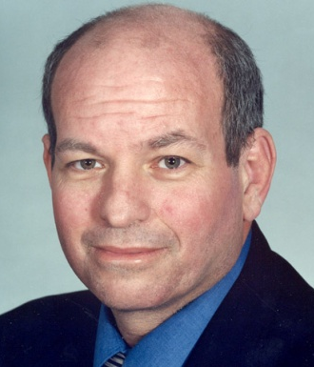
Name and contact information:
Gary K. Davis
301-713-0100 x 149
gary.davis@noaa.gov

Job/Position Title:
Director, Office of Systems Development
Affiliation:
U.S. Department of Commerce,
National Oceanic and Atmospheric Administration,
National Environmental Satellite Data and Information Service
City/State:
Silver Spring, Maryland
Websites:

http://www.commerce.gov/
http://www.noaa.gov/
http://www.nesdis.noaa.gov/
http://www.osd.noaa.gov/

The 2010 Barry M. Goldwater Educator Award is presented by the AIAA National Capital Section to Gary K. Davis for demonstrated leadership, dedication, and contributions to education and professional development in the advancement of the nation’s operational civil environmental satellites and associated support systems and technologies.

Mr. Davis has led the development of the nation’s operational civil environmental satellites and associated support systems since 1997 as the Director of the Office of Systems Development at the National Oceanic and Atmospheric Administration (NOAA), National Environmental Satellite, Data and Information Service (NESDIS). Over a 35-year career he has overseen 32 launch campaigns for these systems and coordinated with Directors from meteorological agencies internationally, including the Europeans and the United Nations World Meteorological Organization. He helped to change standard operating procedure for launches to an in-orbit storage method that resolves the problems associated with launch uncertainty. This experience informs his lectures around the world on the history of environmental monitoring from space, and his local work with the organization of the Eleanor Roosevelt High School Science Fair, one of the largest technology and science fairs in Maryland. Mr. Davis has received numerous awards and recognition including the Presidential Rank Award.

Mr. Davis currently lives in Maryland with his wife Mona. They have two children, a daughter named Kelly who serves as a lawyer/congressional liaison for NASA in Washington DC and a son Andrew who is a defense contractor in Maryland; and two grandchildren.

