February 2019 Agenda
Current Officers
Attendance | Name | Position
 | Joshua Leopardi | Chairman
 | Joseph Baggs | Vice-Chairman
 | Kevin Smith | Treasurer
 | Rick Yuan | Secretary
 | Abby Bierschbach | Programs
 | Vacant | Honors & Awards
 | Kristina McLaughlin | Education
 | Tom Stevens | K-12 Outreach
 | Vacant | RAC Representative
 | Vacant | Career & Workforce Development
 | Cheyenne Jones | Young Professionals
 | Vacant | Membership
 | Vacant | Technical Committee
 | Vacant | Public Policy
 | Joshua Leopardi | Newsletter Editor
 | Joshua Leopardi | Webmaster

Attendance:
- Hails/Farewells
  - Hails –
  - Farewells –

- Treasurer financial report:
Checking Balance | $1,684.63
Savings Balance | $241.73
Expenditures | $0
Total ending balance | $1,998.63
T-Shirts are here!!! $25.00 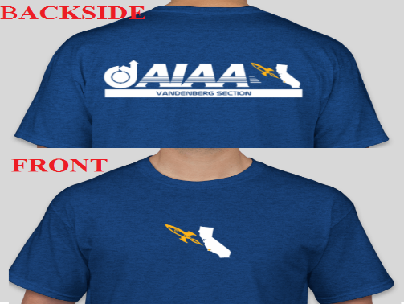

- Topics
  - TARC
    - Vandenberg Middle School and Civil Air Patrol creating teams
  - Civil Air Patrol
    - High Altitude Balloon program, Demo flight for STEM Expo

- Programs

- Todd Barber for next Distinguished Lecture on Cassini need dates!
- Trips to STEM centric museum – VAFB Space Museum? Where, who, it’s been two months and still not movement yet.
- Star Party – Vandenberg Amateur Astronomical Society – Any status
http://www.centralcoastastronomy.org/calendar/?month=oct&yr=2018

- Honors & Awards

- Education
  - VAFB Library – STEAM Learning, Wednesday’s 1330-1530,
  - A+ Certification Book Club, Wednesday’s 1530-1630,
  - Robotics, Wednesday’s 1630-1730,
  - Call for Papers: 2019 Propulsion and Energy Form 31 Jan 2019 Deadline

- Young Professionals
  - AIAA Region VI Student Conference 2019 - Yakimenko, Oleg oayakime@nps.edu
  - In need of six judges – see Abby Bierschbach for info
  - AIAA Vice President at Cal Poly working tour on base. WROCC and needing other facilities.

- Public Policy
  - 2019 Congressional Visits Day – Registration is open, March 19-20 at Washington D.C., who is interested, officers will have priority.
      - Matthew J. Angiulo: angiulo@raytheon.com

- K-12 Outreach
  - See Attachment

- Webmaster
  - WERE BACK ON TWITTER!
  - AIAA Vandenberg Webpage/ “Engage.aiaa.org”
Engage is the new website that AIAA is going to. They are currently in beta testing out individual section communities. Please log on and create your account to stay up to date with our section.
COMMENTS:

